Tilapiers: A YOLOv8-Based Intelligent Behavior Analysis and

Automated Feeding System for Tilapia

A Thesis 1 Project by:
Castillo, John Lawrence S.
Figuracion, Nick Jamesly M.
Masi, Ferdinand Jr. T.
Urbano, Julian J.

Submitted to the Computer Science Department
Technological Institute of the Philippines – Quezon City
In Partial Fulfillment
of the Requirements for the Course
CS 307 – Thesis 1
August 2026

Table of Contents
- Chapter 1 Introduction 1
Background of the Study 2
Objectives of the Study 6
Significance of the Study 7
Scope 9
Delimitations 18

- Chapter 2 Review of Related Literature 24
Foreign Literature 24
Local Literature 31
Synthesis and Research Gap 33
Research Paradigm of the Proposed System 35
Conceptual Framework of the Proposed System 37
System Architecture 39
System Flowchart 42
Definition of Terms 61

- Chapter 3 Research Methodology 72
Research Design 72
Project Design 75
Computing Standards, Modern Tools, and Techniques 80
Project Development 83
Multiple Constraints and Trade-off Analysis 91
Design Trade-offs 95
Trade-off Analysis 96
Sensitivity Analysis 97
Algorithm Implementation 99
Environmental Verification Gate 100
YOLOv8 Feed-Pellet Detection and Counting 102
Depletion-Responsive Feeding Decision Algorithm 104
Model Training and Parameter Configuration 108
Testing and Operating Procedure 109
Project Evaluation 115
Work Plan (Work Breakdown Structure) 116
Potential for Commercialization 117
Market Model 117
Measurable Benefits 118
Three-Year Product Roadmap 120
Go-to-Market Strategy 121
Business Model 122
References 124

List of Table
Table 1 Culture stage and feed specifications 10
Table 2 Binary environmental classification 12
Table 3 Depletion-rate response classification 15
Table 4 Comparison of reviewed studies and Tilapiers 34
Table 5 Definition of Terms 71
Table 6 System Features and Design Basis by Operational Module 80
Table 7 Computing Standards, Tools, and Techniques Applied Across the Methodology 83
Table 8 Correspondence Between V-Model Development Stages and Test Levels 85
Table 9 Comparison of Candidate YOLO Version Variants 96
Table 10 Parameters for Sensitivity Analysis 99
Table 11 Testing Strategy by Level and ISO/IEC 25010 Characteristic 112
Table 12 Statistical Treatment and Verbal Interpretation Scale for Project Evaluation 116

List of Figures
Figure 1 Research Paradigm 35
Figure 2 Conceptual Framework 37
Figure 3 System Architecture 39
Figure 4 Main Menu Module 43
Figure 5 Water Temperature Monitoring Module 44
Figure 6 Temperature Status Module 45
Figure 7 Dissolved Oxygen Monitoring Module 46
Figure 8 DO Status Module 47
Figure 9 Fish Feeding Evaluation Module 48
Figure 10 Safe Feeding Execution Module 49
Figure 11 Reduce Feed Module 50
Figure 12 Profile Management Module 51
Figure 13 Add Staff Module 52
Figure 14 Archive Staff Module 53
Figure 15 Assign Admin Module 54
Figure 16 Maintenance Module 55
Figure 17 Security Module 56
Figure 18 Backup Module 57
Figure 19 Restore Module 58
Figure 20 FAQ Module 59
Figure 21 About Us Module 60
Figure 22 V-Model Diagram 84
Figure 23 Tilapiers Algorithm Implementation Flow 100
Figure 24 YOLOv8 Architecture 102
Figure 25 Depletion-Responsive Feeding Decision Algorithm 105
Figure 26 Gantt Chart 116
Figure 27 Market Model 118
Figure 28 Three-Year Product Roadmap 120
Figure 29 Go-to-Market Strategy 121
Figure 30 Business Model Summary 123

CHAPTER 1

Introduction
Aquaculture is a rapidly growing food-production sector, with Nile tilapia (Oreochromis niloticus) widely cultivated for its rapid growth and environmental adaptability (Yagoub et al., 2026). Water temperature affects tilapia metabolism and appetite, while dissolved oxygen (DO) is essential for respiration. Based on consultation with the BFAR-NCR Fisheries Production Section, a DO level of at least 5 mg/L is adopted as the minimum feeding threshold in this study (personal communication, 2026).
Traditional tilapia feeding relies on manual observation and estimated quantities, potentially causing overfeeding, water pollution, and unnecessary feed waste, or underfeeding that affects fish growth. These practices may overlook changing environmental conditions and actual feeding activity. Advances in the Internet of Things (IoT) and computer vision provide opportunities to improve feeding management. Riyandani et al. (2023) demonstrated YOLOv5x-based feed pellet detection, achieving 82% accuracy and 81.90% mean Average Precision (mAP). Low-cost sensors can also continuously monitor water temperature and dissolved oxygen (Sangkaphet et al., 2026).
Tilapiers is a web-based system that combines environmental monitoring and automated feeding. Feeding occurs only when temperature and dissolved oxygen meet safety thresholds. A reference starter dose is recalibrated weekly using sampled fish weight and the applicable Month 2–4 feeding rate. Computer vision monitors pellet depletion every five minutes to adjust or stop feeding, helping reduce waste and maintain water quality.

Background of the Study
Aquaculture now accounts for about half of global aquatic animal production, 51% in 2022, surpassing capture fisheries for the first time (Food and Agriculture Organization of the United Nations [FAO], 2024), and Nile tilapia ranks among the top cultured freshwater fish globally. Small-scale operations and research setups consistently encounter operational bottlenecks stemming from feeding practices that are schedule-based or judgment-based rather than continuously informed by the tank's actual physiological conditions.
At the biological level, water temperature and dissolved oxygen jointly influence tilapia metabolism, respiration, and voluntary feed intake. Water temperature and feeding frequency have been shown to interact significantly, affecting metabolic activity and growth performance in juvenile Nile tilapia, with appetite-related hormones fluctuating with water temperature (Hamed et al., 2024). Islam et al. (2022) showed that tilapia held at elevated temperatures (31–37°C) exhibited increased oxygen consumption and altered gill morphology, while Liu et al. (2022) demonstrated that lethal cold stress (12°C) triggered mitochondrial dysfunction and cell apoptosis. Elevated temperature does not act on appetite in isolation; it also reduces the water's dissolved oxygen capacity, meaning heat-driven and oxygen-driven feeding disruption are physiologically linked rather than independent phenomena. These findings from peer-reviewed literature establish the physiological basis for treating temperature and dissolved oxygen as related, feeding-relevant parameters that are equally capable of making feeding unsafe; the specific numeric thresholds this study applies operationally, however, are drawn separately from the BFAR-NCR field consultation and from the system's own pilot calibration, and the two sources are not treated as equivalent.
Separately from environmental gating, feeding quantity in the field is not typically computed from a per-session estimate of body weight or live fish population. Instead, according to the study's BFAR-NCR consultation, practitioners follow an incremental, response-based method: dispensing a portion of feed, observing whether it is consumed over a short window (commonly 3–5 minutes), and continuing or halting based on whether feed remains visible. Overfeeding is understood in the field primarily through its consequence: uneaten feed sinks, decomposes, drives bacterial loading, and degrades water quality, sometimes fatally. This makes the feeding zone itself, not the individual fish's estimated size or the tank's population count, the most direct, observable indicator, within this consultation's account of field practice, of whether a feeding session should continue.
On the technical side, object detection architectures have advanced rapidly enough to make this field-observed behavior computable. The YOLOv5x-based fish-feed detection and quantification system of Riyandani et al. (2023) was trained on 1,024 labeled underwater images of floating 2 mm feed pellets, achieving 82% accuracy, 80% precision, 84% recall, an 81.90% mAP, and a training loss of 0.079144. The model distinguished feed pellets from visually similar objects, air bubbles, fish waste, and the fish themselves as separate detection classes, and remained accurate even when pellets were closely clustered. Its depletion-tracking results further showed that, across morning, afternoon, and evening feeding sessions, detected pellet counts declined in a consistent pattern, typically approaching zero by around the 25th minute after dispensal. This model's detection accuracy was validated against a labeled test set; it was not independently validated that a disappeared pellet corresponds to actual ingestion, and this study inherits the same limitation, discussed further under Delimitations. These results nonetheless demonstrate that feed-pellet quantification, rather than fish detection or biomass estimation, can serve as an observable proxy for consumption behavior, consistent with the incremental, observation-based approach described in this study's BFAR-NCR consultation. Because the floating pellets used in this study are larger than the 2 mm pellets of the referenced system (2.8–4.3 mm across the culture stages covered; see Table 1), the detection model must be trained on the study's own pellet images rather than assumed to transfer directly.
To address these gaps, Tilapiers introduces a system that (1) uses continuous temperature and dissolved oxygen sensing as a binary safety gate that permits feeding only when both parameters are within their optimal range, withholding feeding and sending an SMS alert to the caretaker whenever either parameter or both falls outside that range, (2) adapts the same YOLOv8-based (Jocher et al., 2023) feed detection and quantification approach to observe a defined feeding-zone region of interest after each dispensed increment, using the resulting pellet-depletion rate to classify the response as high, moderate, or low depletion and thereby govern whether feeding continues, is reduced, or is stopped, while separately flagging uneaten feed as a water-quality risk indicator, and (3) executes the resulting feeding action automatically through the actuator once the decision algorithm determines it, with the web dashboard providing real-time visibility into every reading, recommendation, and action taken. By grounding feeding decisions in the water's classified environmental state and in what is directly observed in the feeding zone, Tilapiers avoids the need for individual fish detection, behavior classification, or per-session biomass estimation, components that add model complexity without changing what the study's field consultation indicates practitioners actually check before they feed.

This study aims to design, develop, and evaluate Tilapiers, an IoT- and computer vision-driven web-based tank monitoring and automated feeding system for Nile tilapia (Oreochromis niloticus) across starter, grower, and finisher stages. The system integrates real-time water quality monitoring for dissolved oxygen and temperature with a YOLOv8 pellet-detection model to dynamically control feed delivery, prevent feeding under environmental stress, and minimize feed waste. Specifically, the study sought to address the following problems:
- Environmental Assessment & Alerting Mechanism:
How can water temperature and dissolved oxygen (DO) levels be continuously acquired, processed, and classified into Safe or Unsafe operational thresholds, and how effectively can an SMS module alert the caretaker during unsafe states to prevent feeding under thermal or hypoxic stress?
- Multi-Class Object Detection & Counting:
How accurately can a fine-tuned YOLOv8 computer vision model detect and classify tilapia, feed pellets, air bubbles, and fish waste, and count the feed pellets, within a specified feeding-zone Region of Interest (ROI) under real-world water surface conditions?
- Closed-Loop Decision & Control Algorithm:
How can a demand-driven feeding algorithm be designed to dispense a reference starter dose in fixed increments and dynamically adjust feeding operations (continue, reduce, or terminate) based on the observed pellet depletion rate within a set observation window to minimize uneaten feed?
- Hardware & Software Architecture Integration:
How can the environmental gating mechanism, computer vision pellet-detection pipeline, adaptive decision algorithm, physical feeder actuator, SMS alert module, and web dashboard be integrated into a cohesive, fully automated precision aquaculture system?
- Integrated System Performance & Evaluation:
How well does the integrated system perform across the following operational and software engineering benchmarks?
- Object Detection Performance: Precision, Recall, F1-score, and mean Average Precision (mAP) across the detected classes (tilapia, feed pellets, bubbles, and waste).
- Depletion & Counting Accuracy: Accuracy in tracking real-time pellet count and feed consumption rates.
- Environmental Reliability: Classification accuracy of environmental stress states and SMS delivery success rate/latency.
- System Responsiveness: End-to-end latency from visual recommendation to physical actuator execution.
- Software Quality Standard: Compliance with the ISO/IEC 25010 software quality model (functional suitability, performance efficiency, and reliability).

Objectives of the Study
This study aims to design, develop, and evaluate Tilapiers, a web-based, temperature- and dissolved-oxygen-aware tank monitoring and automated feeding system for Nile tilapia at the starter, grower, and finisher stages (months 2 to 4 of culture). Specifically, the study aims to:
- To develop a real-time monitoring module that acquires water temperature and dissolved oxygen readings, classifies the environment as Safe (both within optimal range) or Unsafe (either outside optimal range), and sends an SMS alert to the caretaker when Unsafe.
- To train and evaluate a YOLOv8 model that detects tilapia, feed pellets, air bubbles, and fish waste, and counts the feed pellets, within a defined feeding-zone region of interest (ROI).
- To develop a feeding decision algorithm that releases the reference starter dose in fixed increments and continues, reduces, or terminates feeding based on the pellet-depletion rate within a defined observation window.
- To integrate the environmental gate, pellet detection, feeding algorithm, actuator, SMS module, and web dashboard into a fully automated feeding system.
- To evaluate the system's object detection performance (precision, recall, F1-score, mAP, reported overall and per class), pellet-counting and feed-depletion accuracy (against manually verified ground truth), environmental classification accuracy, SMS alert delivery reliability, recommendation-to-execution latency, and software quality based on ISO/IEC 25010.

Significance of the Study
This study contributes to intelligent aquaculture technology by developing Tilapiers, a real-time, temperature and dissolved-oxygen-aware tank monitoring and depletion-responsive feeding system for Nile tilapia. By integrating computer vision-based feed-pellet detection and quantification, continuous environmental sensing, SMS-based caretaker alerting, and web-based monitoring into a single platform, the system aims to provide an objective, observation-based approach to feeding management that mirrors the incremental field practice described in this study's BFAR-NCR consultation, rather than relying on a static schedule or a per-session, estimation-derived ration formula.
Tilapia Farmers: The system may help farmers make feeding decisions grounded in real-time pellet-depletion observations and a classified environmental state, reducing feed wastage, improving water quality outcomes, and reducing feeding losses during thermal or low-oxygen conditions. Feeding is withheld whenever the environment is classified as Unsafe, and the caretaker is promptly alerted by SMS when such conditions occur.
Tilapia Hobbyists and Home Aquarium Enthusiasts: The system may provide an accessible, automated way to help prevent overfeeding and its downstream water-quality consequences without requiring specialized measurement equipment or expertise.
Bureau of Fisheries and Aquatic Resources NCR (BFAR): The system's low-cost, replicable design, informed by the field practices described in this study's BFAR-NCR consultation, may serve as a practical model for precision aquaculture extension programs targeting small-scale and municipal fish farmers.
Aquaculture Industry under BFAR-NCR: Stakeholders may use the system as a reference for combining depletion-responsive feeding logic with real-time environmental verification and SMS-based alerting in fish farming operations.
Students, Researchers, and Software Developers: This study demonstrates a practical application of computer vision, IoT sensing, and closed-loop control logic to a real-world agricultural problem, and may guide future work on depletion-based feeding systems, feeding-zone monitoring, and sensor-gated automation for aquaculture.
Future Researchers: Future researchers may extend this framework by incorporating additional environmental parameters, extending its multi-species applicability, or adopting more advanced depletion-detection modeling, such as corroborating pellet decline with fish-presence signals in the feeding zone.

Scope
This study focuses on the design, development, and system evaluation of Tilapiers within a controlled, small-scale outdoor tank setup measuring 81 cm × 109 cm with a depth of 72 cm, using 20 Nile tilapia (GET EXCEL) supplied by BFAR at the starter, grower, and finisher stages, corresponding to approximately the second, third, and fourth months of culture, conducted at a BFAR-provided facility.
Feeding in the study uses Tateh ExtruFloat Premium, a floating extruded tilapia feed (Tateh, n.d.), with the pellet size matched to each culture stage: 2.8 mm to 3.2 mm for the starter stage, 3.3 mm to 3.7 mm for the grower stage, and 3.8 mm to 4.3 mm for the finisher stage.

Culture month | Growth stage | Pellet size (Tateh ExtruFloat Premium) | Average body weight (ABW) | Feeding rate (% of biomass per day) | Feeding frequency
Month 2 | Starter | 2.8–3.2 mm | 36–99 g | 5% | 4 times a day
Month 3 | Grower | 3.3–3.7 mm | 127–221.5 g | 3% | 3 times a day
Month 4 | Finisher | 3.8–4.3 mm | 256.5–361.5 g | 2% | 2 times a day

Table 1 Culture stage and feed specifications
Pellet sizes are from Tateh (n.d.). Average body weight, feeding rate, and feeding frequency are from the BFAR-NCR extension feeding guidelines (Bureau of Fisheries and Aquatic Resources Regional Office No. 8, n.d.). The fry stage (month 1) is outside the study's scope.
The hardware pipeline incorporates a water-temperature sensor and a dissolved-oxygen sensor, each to be validated against reference instruments during system development, to track the two environmental parameters used by the system's verification gate. A camera module captures real-time video feeds focused on a defined feeding-zone region of interest (ROI), where a YOLOv8-based model detects and counts visible feed pellets in real time, from which pellet-depletion status and uneaten-feed conditions are determined. An SMS/GSM module sends alert messages to the caretaker's registered mobile number whenever the environment is classified as Unsafe. Unlike approaches that size feed rations from live fish population counts or per-session body-weight estimates, Tilapiers determines feeding permission from the binary environmental gate and feeding continuation and quantity from the observed rate of feed-pellet depletion within the feeding zone, with the starter dose itself calibrated manually at stocking and at each change of culture stage.
The core software innovation of this project is an environment-gated, depletion-responsive feeding decision algorithm deployed in a web application. The environmental verification gate classifies current temperature and dissolved-oxygen readings into a binary Safe or Unsafe state using fixed, non-overlapping threshold bands informed by peer-reviewed literature, the study's BFAR-NCR field consultation, and the optimal temperature and dissolved-oxygen standards for Class C freshwater intended for the propagation and growth of fishery species set under DENR Administrative Order No. 2016-08 (DENR, 2016), refined through the study's own tank pilot calibration. The environment is classified as Safe only when both temperature and dissolved oxygen fall within their respective optimal ranges simultaneously; if either parameter, or both, falls outside its optimal range, the environment is classified as Unsafe. This reflects the position established earlier in this chapter that dissolved oxygen governs the fish's most immediate physiological need. A favorable temperature reading cannot compensate for it, and a single unfavorable parameter is sufficient to withhold feeding regardless of the others. Table 2 summarizes the environmental-state-to-recommendation mapping; every possible temperature and dissolved-oxygen reading falls into exactly one state, with no gaps or overlaps between bands.
Environmental State | Temperature Range | Dissolved Oxygen Range | System Recommendation
Safe | 25°C ≤ T ≤ 31°C | DO ≥ 5 mg/L | Feeding recommended; incremental dispensing begins, governed by pellet-depletion classification.
Unsafe | T < 25°C or T > 31°C | DO < 5 mg/L | Feeding withheld entirely; SMS alert sent to the caretaker's registered mobile number.

Table 2 Binary environmental classification
Strict, non-overlapping ranges based on DENR Administrative Order No. 2016-08, the study's BFAR-NCR field consultation, and pilot calibration. Any single out-of-range parameter (temperature, dissolved oxygen, or both) is sufficient to classify the environment as Unsafe.
Once the environment is classified as Safe, a fixed reference starter dose (D_ref) governs the session. D_ref is the per-session portion of the daily ration: the stage-specific daily feeding rate applied to the caretaker's approximate stocked biomass, divided by the stage-specific number of feedings per day (Table 1). It is calibrated at stocking and recalibrated only when the culture stage changes, informed by BFAR-NCR extension feeding guidelines (BFAR-NCR Fisheries Production Section, personal communication, 2026) and consistent with the feed-management practices described for tilapia culture in ponds in the Bureau of Fisheries and Aquatic Resources Regional Office No. 8 Techno Guide Series flyer, Tilapia in Ponds (BFAR Regional Office No. 8, n.d.). Rather than proposing the full session ration at once, the system releases feed in fixed-size increments and monitors the feeding zone after each increment: the resulting pellet-depletion rate is classified into one of three tiers, and the system's next action depends on that classification rather than on a single continue/stop decision. This keeps the feeding logic explicit and testable rather than relying on an implied or unstated response rule.
Feeding Decision Algorithm
The environment-gated, depletion-responsive feeding decision algorithm, designed with reference to the incremental, observation-based feeding practice for tilapia described in the Tilapia in Ponds flyer and to the optimal water-quality standards of DENR Administrative Order No. 2016-08, is defined as follows. Consistent with the study's scope, the algorithm covers Months 2 to 4 of the culture period (Month 1 fry-mash feeding is excluded).
D_ref = fixed reference starter dose, recalibrated weekly from
sampling data (average body weight of 50 pcs per 1,000
stock), using the applicable Month 2–4 feeding rate and
frequency
increment_size = 0.25 × D_ref
observation_window = 5 minutes
stage = classify_stage(ABW_sample):
IF 36 ≤ ABW_sample ≤ 99: stage = Month 2 (rate = 5%, freq = 4, feed = "Starter floater")
ELIF 127 ≤ ABW_sample ≤ 221.5: stage = Month 3 (rate = 3%, freq = 3, feed = "Grower floater")
ELIF 256.5 ≤ ABW_sample ≤ 361.5: stage = Month 4 (rate = 2%, freq = 2, feed = "Finisher floater")
ELSE: flag out-of-range ABW; hold last valid stage
D_ref = (ABW_sample × stage.rate × No. of Stocks) / (1000 × stage.freq)
state = classify(temperature, dissolved_oxygen) → Safe or Unsafe
IF state == Unsafe:
withhold feeding entirely
send SMS alert to caretaker's registered mobile number
log environmental readings and Unsafe classification
END
IF state == Safe:
dispensed = 0
WHILE dispensed < D_ref:
dispense(increment_size)
dispensed += increment_size
P0 = pellet_count()
wait(observation_window)
Pt = pellet_count()
R = (P0 − Pt) / P0
IF R ≥ 0.8: classify High depletion → continue: next full increment
ELIF R ≥ 0.4: classify Moderate depletion → reduce: half increment
ELSE: classify Low depletion → stop; log Pt as uneaten-feed alert; BREAK
IF dispensed == D_ref:
STOP; log "session cap reached"
Depletion Rate (R) | Classification | System Action
R ≥ 0.8 (≥ 80% gone) | High depletion | Continue: dispense the next full increment (same fixed size).
0.4 ≤ R < 0.8 | Moderate depletion | Reduce: dispense a half increment.
R < 0.4 | Low depletion | Stop: withhold further feed; log remaining pellets as an uneaten-feed alert.

Table 3 Depletion-rate response classification
The 0.8 and 0.4 cut-offs and the five-minute window are initial values to be confirmed or adjusted during pilot calibration. The table summarizes the resulting response classification. This tiered structure resolves "continue" into three distinct, threshold-driven actions rather than a single undifferentiated response, so that a session with strong depletion is treated differently from one with weak or ambiguous depletion.
The reference dose functions as a hard ceiling for the session: regardless of how many increments are dispensed or how consistently the detector reports high depletion, total dispensed feed cannot exceed D_ref. This bounds the impact of a sustained run of false or overly optimistic depletion readings, so that even a systematically biased detection stream cannot drive past the pre-set ceiling for that session.
Each increment is dispensed automatically by the actuator as soon as the decision algorithm determines it, without requiring caretaker action. The web dashboard displays the detection evidence underlying each dispensed increment (the pellet count and a corresponding frame or short clip) in real time, so the caretaker can review what the system observed and acted on, without needing to approve the action beforehand.
System telemetry, comprising environmental readings, feed-pellet counts, feeding-session depletion status, uneaten-feed alerts, SMS alert logs, low-confidence and anomaly flags, and dispensing execution logs, is accessible to caretakers via the web-based dashboard.
System Modules
The system consists of the following operational modules, as reflected in the system flowchart:
- Main Menu and Authentication Module: Verifies caretaker or staff login credentials against the database and routes the user to the system's primary functions: water temperature monitoring, dissolved oxygen monitoring, fish feeding, profile management, maintenance, security, FAQ, and About Us.
- Water Temperature Monitoring Module: Continuously reads, processes, and logs water temperature data from the tank thermometer for live display. One hour before a scheduled feeding session, it evaluates whether the reading falls within the optimal range and passes control to the Temperature Status Module if it does not.
- Temperature Status Module: Checks stored temperature data against the safe threshold to determine whether the reading is below or above the optimal level, and dispatches an SMS alert to the caretaker when an abnormal thermal state is detected.
- Dissolved Oxygen Monitoring Module: Continuously reads, processes, and logs dissolved oxygen data from the DO sensor for live display. One hour before a scheduled feeding session, it evaluates whether the reading is optimal and passes control to the DO Status Module if it is not.
- DO Status Module: Checks stored dissolved oxygen data against the required threshold to identify hypoxic or unsafe conditions, and transmits an SMS warning to the caretaker when levels fall below the optimal range.
- Fish Feeding Evaluation Module: Retrieves the latest temperature and dissolved oxygen readings to confirm whether both environmental conditions and the scheduled feeding time align. If both gating checks pass, the workflow proceeds to Safe Feeding Execution; otherwise, feeding is halted and the system returns to the main menu.
- Safe Feeding Execution Module: Retrieves the fixed reference starter dose (D_ref) set for the current culture stage and dispenses it in fixed increments of 25% of D_ref. After each increment, it observes the feeding zone over a five-minute interval and computes the pellet-depletion rate: high depletion continues full increments, moderate depletion routes to the Reduce Feed Module, and low depletion stops feeding and logs the remaining pellets as an uneaten-feed alert. Total dispensed feed never exceeds D_ref.
- Reduce Feed Module: Cuts the next increment to 50% of the fixed increment size when moderate depletion is detected, then re-evaluates pellet depletion after the five-minute window to either restore the full increment, continue at the reduced size, or terminate feeding entirely.
- Profile Management Module: Verifies administrator credentials and allows authorized users to add staff accounts, archive existing employee profiles, or reassign admin privileges (via its Add Staff, Archive Staff, and Assign Admin sub-modules).
- Maintenance Module: Issues a weekly camera- and feeder-cleaning reminder and automatically sends an SMS reminder to caretakers every Saturday.
- Security Module: Provides administrators with options to back up current data records or restore a prior database state, safeguarding operational logs through its Backup and Restore sub-modules.
- FAQ Module: Displays interactive tutorials and operational guidance for each main menu task, allowing users to browse multiple topics before returning to the main menu.
- About Us Module: Displays programmer information, the program's publication date, and the system's mission statement.

Delimitations
- Environment scope: Performance under commercial open-pond, cage, or low-visibility outdoor aquaculture environments remains unverified beyond the study's outdoor BFAR-provided tank setup.
- Vision detection scope: The detection module is trained to detect and count feed pellets within a defined feeding-zone ROI; it does not detect, count, or classify individual fish, diagnose disease, estimate fish size, or weight.
- Feed type and pellet size scope: The study uses a single feed product, Tateh ExtruFloat Premium floating extruded feed (Tateh, n.d.), at three pellet-size ranges: 2.8–3.2 mm (starter), 3.3–3.7 mm (grower), and 3.8–4.3 mm (finisher). The detection model is trained and evaluated only on these pellet sizes and this feed's appearance; performance with other feed brands, sinking feeds, or pellet sizes outside these ranges is not verified.
- Environmental parameters: The environmental monitoring module is limited to two parameters: water temperature and dissolved oxygen. No other water-quality parameters (e.g., pH, turbidity, ammonia) are sensed or used by the feeding decision algorithm.
- Feeding decision scope: The system determines feeding permission based on the binary environmental gate and determines dose continuation using a fixed reference starter dose released in fixed-size increments, with tiered adjustment based on real-time feed-pellet depletion classification; it does not perform live fish counting, population estimation, or individual-fish biometric estimation during operation.
- Depletion detection scope and terminology: The camera-based module detects a decline in visible pellet count within the ROI, referred to in this study as visible feed-pellet depletion, a proxy for consumption rather than direct proof of ingestion. Pellets may disappear from the ROI for reasons other than being eaten, including sinking outside the ROI, water movement or drift, and occlusion by other pellets or by fish. Ground-truth validation under Objective 5 evaluates how closely this proxy tracks manually verified pellet presence, but does not eliminate this source of error. Feeding-zone monitoring is further calibrated for the study's fixed camera position, lighting, and ROI definition at the BFAR tank setup; accuracy is bounded by water clarity and lighting consistency, and generalization to other water-clarity conditions is not verified beyond what is captured through data augmentation during model development.
- Feeding quantity regulation and biomass calibration: The starter dose is a fixed reference amount, not recalculated per session. At setup, the caretaker manually enters an approximate total stocked biomass, derived from an approximate fish count and the average body weight for the current growth stage (36–99 g for the starter stage, 127–221.5 g for the grower stage, and 256.5–361.5 g for the finisher stage; Table 1); this single figure is used, together with the stage-specific daily feeding rate (5%, 3%, and 2% of biomass per day for the starter, grower, and finisher stages, respectively, per BFAR-NCR extension guidelines) and feeding frequency (4, 3, and 2 times a day, respectively), to compute the fixed per-session reference starter dose. This dose then remains fixed until the caretaker manually updates it, such as after harvest, restocking, or a change of culture stage. During live operation, the dose is adjusted only by the binary environmental Safe/Unsafe gate and real-time pellet-depletion classification, not by individualized nutritional modeling, live population count, or continuous biomass estimation via computer vision. The real-time detection pipeline never estimates fish weight, count, or biomass; it only ever observes pellets within the feeding-zone ROI.
- Growth stage scope: The system covers the starter, grower, and finisher stages (approximately months 2 to 4 of culture), with the reference starter dose and pellet size set per stage as shown in Table 1. Growth stages outside this range (the fry and fingerling stages before month 2, and fish held beyond month 4) are outside this study's scope and are noted as an area for future extension. The stage is selected and the dose recalibrated manually by the caretaker; the system does not detect growth-stage transitions automatically.
- SMS alert scope: The SMS alert notifies the caretaker only that the environment has been classified as Unsafe at the time of the reading; it does not diagnose which parameter (temperature, dissolved oxygen, or both) caused the classification within the message itself, nor does it track whether the caretaker has read or acted on the alert. Delivery also depends on cellular network availability at the deployment site and on the reliability of the third-party SMS gateway or GSM module used, which are outside the study's direct control.
- Correlation algorithm: The feeding decision algorithm relies on fixed temperature and dissolved-oxygen threshold bands established by peer-reviewed literature, the study's field consultations, and DENR Administrative Order No. 2016-08, rather than on dynamically self-adjusting logic that responds to seasons or detects fish life-stage changes automatically. It is a deterministic, rule-based control algorithm and does not compute a statistical correlation coefficient between variables. An earlier three-tier (Safe/Caution/Critical) design was simplified to a binary Safe/Unsafe classification during development, on the basis that dissolved oxygen and temperature are treated as equally disqualifying rather than independently weighted.
- Fail-safe and anomaly handling: To limit the impact of false, missing, or noisy detections, the system enforces a hard session dose ceiling regardless of how many increments are dispensed, suppresses depletion readings that fall below a minimum detection-confidence threshold (holding the previous state and flagging a low-confidence read rather than feeding that reading into the decision logic), and flags implausibly rapid depletion, inconsistent with expected depletion timeframes reported in the literature, for caretaker review rather than auto-classifying it as high depletion. Any invalid sensor reading, camera dropout, or network failure likewise defaults the system to no feeding action and, where the failure prevents environmental classification entirely, triggers an SMS alert as a precaution. The web dashboard displays the detection evidence for every dispensed increment, allowing the caretaker to review it after the fact.
- Automation scope: The system is designed as a fully automated feeder. All sensing, gating, dose calculation, depletion monitoring, and the physical dispensing action itself are executed automatically by the system without requiring caretaker approval before each feeding increment. The caretaker's role is limited to initial system setup (e.g., entering the stocked biomass estimate and selecting the culture stage), post hoc review of feeding activity and alerts via the web dashboard, and responding to SMS alerts when the environment is classified as Unsafe.
- Operating assumptions: The system's real-time performance and alerting mechanisms assume uninterrupted electrical power, clear camera optics, continuous connectivity between the microcontroller, the computer vision processing unit, the web application, and the feeding mechanism; a caretaker who is reasonably available to respond to SMS alerts and review dashboard activity within a practical timeframe; and availability of cellular network coverage at the deployment site for SMS alert delivery.

CHAPTER 2

Theoretical Framework
This chapter presents the theoretical and conceptual foundations supporting the development of Tilapiers, an automated feeding system for Nile tilapia that integrates environmental sensing with computer vision-based feed monitoring. It begins by examining the biological relationship between water temperature, dissolved oxygen, and fish physiology, establishing why these parameters must be treated as interdependent gating conditions rather than isolated variables, a foundation that justifies the system's core design choice of withholding feeding whenever either reading falls outside safe ranges. The chapter then reviews existing applications of Internet of Things (IoT) technology in aquaculture alongside computer vision approaches, particularly YOLOv8-based object detection, for feed-pellet identification and quantification, explaining the rationale behind adopting a pellet-centered detection method over more complex fish-behavior or biometric estimation approaches.
The chapter further synthesizes related foreign and local studies to situate Tilapiers within the broader body of precision aquaculture research, identifying the specific gap the study addresses: the absence of a unified system combining binary environmental gating with real-time, depletion-responsive feeding control. It concludes with the research paradigm and conceptual framework, which outline how the reviewed literature and system requirements translate into the study's inputs, processes, and expected outputs.

Review of Related Literature
This section reviews foreign and local literature relevant to Tilapiers. Foreign literature is presented first and covers the physiological basis for environmental gating, IoT and ESP32-based aquaculture systems, computer vision for feed-pellet detection, computer vision for fish behavior and appetite analysis, and the YOLOv8 architecture. Local literature follows and covers Philippine IoT, ESP32, and computer-vision studies. A synthesis at the end identifies the gap the study addresses.

Foreign Literature

Water Temperature, Dissolved Oxygen, and Fish Physiology
The relationship between the aquatic environment and fish biology establishes that water temperature and dissolved oxygen not only influence survival but also jointly govern metabolic function, respiration, and feeding readiness. As poikilothermic organisms, Nile tilapia lack an internal mechanism to regulate body temperature, so ambient water temperature directly determines metabolic rate, digestive enzyme activity, and appetite-regulating neurohormones. Dissolved oxygen, meanwhile, governs the fish's most immediate physiological need, respiration, and the two parameters are physiologically linked rather than independent: elevated water temperature reduces the water's capacity to hold dissolved oxygen, so a rise in temperature compounds thermal stress with respiratory stress. This is illustrated directly by Refaey et al. (2025), who found that Nile tilapia held under chronic hypoxia (dissolved oxygen approximately 1.0 mg/L) developed measurable oxidative stress, altered hematological parameters, and degraded flesh quality relative to fish reared under normal dissolved-oxygen conditions, showing that low DO alone, independent of temperature, produces physiological harm.
Hamed et al. (2024) found that water temperature and feeding frequency interact significantly to affect metabolic activity, dissolved oxygen consumption, and growth performance in juvenile Nile tilapia. Their study, which reared fish at 26, 28, and 30°C under one or two daily feedings, reported that fish held at 30°C showed elevated leptin expression and suppressed cholecystokinin expression, while fish held at 26°C showed the reverse pattern, indicating that appetite-related signaling itself shifts with water temperature rather than remaining constant. Extending this relationship beyond the juvenile stage, Islam et al. (2022) exposed Nile tilapia to 31°C, 34°C, and 37°C for 28 days. They found that oxygen consumption rose significantly at 37°C, accompanied by progressively severe gill histopathology, including epithelial necrosis and lamellar fusion, while no significant change occurred at 31°C. At the opposite extreme, Liu et al. (2022) demonstrated that Nile tilapia subjected to lethal cold stress at 12°C developed mitochondrial swelling, structural tissue damage, and apoptosis in the brain and liver, with a median survival time of roughly three days during that exposure. Read together, these studies bound the fish's safe thermal range from both directions and show that departures from it produce measurable physiological harm rather than a benign shift in appetite alone.
These findings supply the biological justification for Tilapiers' environmental verification gate. Rather than dispensing feed on a fixed schedule or at the caretaker's discretion, Tilapiers continuously classifies water temperature and dissolved oxygen into a binary Safe or Unsafe state and permits feeding only when both readings simultaneously fall within their respective optimal ranges. Because a single unfavorable parameter is sufficient, by itself, to indicate that the fish are not physiologically ready to feed, the system does not average or offset one parameter against the other. This positions temperature and dissolved oxygen as the first-stage gate that every feeding recommendation must clear before pellet-depletion monitoring is engaged at all.

Internet of Things and ESP32-Based Systems in Aquaculture
Continuous sensor-driven monitoring has increasingly been applied in aquaculture to provide environmental information without relying exclusively on periodic manual measurements. Sangkaphet et al. (2026) developed and field-tested a LoRa-enabled system for cage-based tilapia farming that classified dissolved oxygen, pH, and temperature into Normal, Surveillance, and Critical states. The system automatically triggered aeration when dissolved oxygen reached a critical condition, while abnormal pH or temperature conditions generated application-based alerts. Field testing reported sub-second detection latency and reliable transmission over distances of up to 1,640 meters. A comparable approach was presented by Chen et al. (2022), whose Taiwan-based aquaculture system monitored temperature, pH, dissolved oxygen, and water level and transmitted the collected information to a mobile interface, incorporating a robotic arm for automatic sensor calibration and maintenance.
A recurring hardware choice in low-cost aquaculture prototypes is the ESP32 microcontroller, whose built-in Wi-Fi allows sensor readings to be sent to cloud platforms and mobile applications. Ayon et al. (2026) integrated an ESP32 with pH, TDS, temperature, and turbidity sensors and with actuators (a servo feeder and a water pump), using the Blynk IoT platform for cloud connectivity. Their system included an alert mechanism with configurable cooldown periods to prevent notification fatigue. In a 10-liter aquarium test, they reported 96% average sensor accuracy, a 1.2-second response time for anomaly detection, and 97% operational reliability for the automated feeding and water circulation modules. The cooldown design is relevant to Tilapiers' SMS alerting, since brief sensor fluctuations should not generate repeated alerts to the caretaker. The reported evaluation, however, covers sensor accuracy, response time, and operational reliability; it does not report a visual measure of how much dispensed feed was actually consumed.
Together, these implementations establish continuous multi-parameter monitoring, connected to threshold-triggered alerts or actuation, as a practical and already-adopted approach. Their focus, however, is environmental monitoring and automated environmental management, or feeder operation, rather than a feeding decision informed by both the classified environmental state and observed feed depletion. The threshold-based classification used in these systems provides a precedent for Tilapiers' own environmental classification. While the LoRa-based system uses multiple states, Tilapiers simplifies this structure into a binary Safe or Unsafe classification because the environmental gate is intended specifically to determine whether feeding can proceed; an intermediate class would not change the feeding action when either parameter is already out of range. Tilapiers therefore uses environmental classification as an upstream feeding gate, after which the computer-vision module determines the subsequent feeding response.

Computer Vision for Feed-Pellet Detection and Quantification
Computer vision has emerged as a non-intrusive method for monitoring aquaculture conditions by using deep learning architectures to interpret visual information in real time. One application is the detection and quantification of feed pellets rather than the direct monitoring of fish behavior. In this approach, the presence, count, and disappearance of pellets provide a directly observable indication of how much feed remains available for consumption.
Riyandani et al. (2023) developed a YOLOv5x-based system for detecting and counting individual fish feed pellets in underwater video using 1,024 labeled images of floating 2 mm feed pellets. The model achieved 82% accuracy, 80% precision, 84% recall, and 81.90% mean average precision. It also distinguished feed pellets from visually similar objects such as air bubbles, fish waste, and fish. The depletion-tracking results showed that detected pellet counts declined consistently across morning, afternoon, and evening feeding sessions, generally approaching zero at approximately the twenty-fifth minute after feed dispersal. Hu et al. (2021) likewise addressed real-time detection of uneaten feed pellets in underwater images using an improved YOLO-V4 network, which supports uneaten feed as a detectable visual target for feeding management.
This pellet-centered approach is directly relevant to Tilapiers' feed-detection and quantification submodule. The system trains a YOLOv8 model specifically to detect feed pellets within a defined feeding-zone region of interest rather than performing broader fish detection or tracking. A reduction in detected pellet count within this region is treated as an indicator of depletion. This proxy has an important limitation: a reduction in visible pellets indicates that pellets have disappeared from the observed region, but it does not independently prove that the fish have ingested them. Tilapiers therefore treats pellet disappearance as a visual depletion signal rather than as direct proof of consumption, a limitation addressed through the system's feeding logic and delimitations.
Other studies have focused on biometric estimation. Hossam et al. (2024) proposed an integrated system combining YOLOv8-based keypoint detection with IoT water-quality sensors, including temperature, dissolved oxygen, and pH, for precision aquaculture involving Nile tilapia. The system used camera-based measurements to estimate individual fish size and determine corresponding feed quantities. Tilapiers, however, does not calculate a new feed quantity from individual fish measurements during every feeding session. Its reference starter dose is recalibrated weekly from sampled average body weight and is subsequently adjusted during each session according to environmental conditions and observed pellet depletion.

Computer Vision for Fish Behavior Analysis and Appetite Assessment
A separate line of computer-vision research analyzes fish behavior as an indicator of appetite and condition. Zhou et al. (2018) proposed a feeding control method based on near-infrared computer vision and a neuro-fuzzy model. Their work extracted an index describing the feeding behavior of fish from near-infrared images and used it in an algorithm that decides whether feeding should continue or stop during the feeding process. This is the closest foreign precedent to Tilapiers' continue-or-stop logic, but it infers appetite from fish behavior rather than from feed remaining in the water. Hu et al. (2022) similarly reported a computer vision-based intelligent fish feeding system using deep learning techniques. Xu et al. (2006) used computer vision to monitor the behavioral responses of tilapia to acute fluctuations in dissolved oxygen, which shows that behavior captured by camera can reflect environmental stress in this species.
More recent YOLOv8-based work continues this direction. Cai et al. (2025) developed an enhanced YOLOv8n model, referred to as YOLOv8n-HSB, for detecting hypoxic stress behavior in tilapia within recirculating aquaculture systems. The model incorporated a Multi-scale Fusion Pyramid Network, a C2f-Occlusion Perception module, and Dynamic Convolution layers to improve detection under conditions involving small objects, occlusion, complex lighting, and turbidity. The study evaluated vision-derived behavioral signals together with dissolved-oxygen measurements to identify hypoxic stress and mortality-warning behaviors. Qian et al. (2026) introduced PM-YOLO, an enhanced YOLOv8n model incorporating Parallelized Patch-Aware Attention modules and a Minimum Point Distance IoU loss term for real-time detection of fish feeding behavior. Trained using FeedFishDatas, a dataset containing approximately 7,400 images, the model achieved 87.7% precision and 83.5% mAP-50 in complex pond aquaculture environments while maintaining real-time inference speed.
These studies show that fish behavior can serve as a signal of appetite and stress, and that it complements sensor-based measurements. Tilapiers takes a different primary route. Its feeding decision is driven by the environmental gate and by pellet depletion, and the vision module is activated only after the environment has been verified as Safe. Behavior-based appetite indicators are therefore treated as supporting evidence rather than as the basis of the feeding decision, because pellet depletion is a more directly observable and less ambiguous target than fish behavior.

YOLOv8 Architecture in Object Detection
The You Only Look Once family of models represents a widely adopted approach to single-stage object detection, balancing detection accuracy with the computational efficiency required for real-time video processing. YOLOv8, released by Ultralytics, introduced an anchor-free detection head along with backbone and neck refinements intended to improve detection performance for objects under challenging visual conditions (Jocher et al., 2023). These characteristics are relevant to floating feed pellets, which may appear against backgrounds affected by water movement, air bubbles, reflections, and fish activity.
The use of YOLOv8 in aquaculture is further supported by Zhang et al. (2025), who developed FFishNet-YOLOv8 to detect feeding fish in ponds, adapting the architecture for small, densely packed target detection under cluttered pond conditions comparable to those Tilapiers operates in. Tilapiers narrows this application to feed-pellet detection within a fixed feeding-zone region of interest, so the vision component stays focused on the depletion signal required by the feeding algorithm.

Local Literature
Local studies on IoT-based and vision-based tilapia systems are fewer than foreign ones. The studies below are those found to be most relevant to the hardware, alerting, and vision components of Tilapiers in the Philippine setting.

IoT and ESP32-Based Aquaculture Systems in the Philippines
Pines et al. (2026) developed AquaSense, an IoT-based system for automated feeding, water quality monitoring, and aeration in tilapia fishponds in the Philippines. The system combined an ESP32 microcontroller, a DS18B20 temperature sensor, a dissolved-oxygen sensor, a servo motor-driven feeder, and an aerator pump. Feeding schedules were synchronized through the Network Time Protocol, and the Blynk mobile platform provided real-time visualization and remote supervision. The authors tested the system in laboratory and field conditions and reported consistent 40-second dispensing cycles at programmed times. A survey of 50 fishpond operators rated the system "Very Satisfied" for effectiveness (4.50), accuracy (4.58), and reliability (4.44). The authors selected temperature and dissolved oxygen as the monitored parameters because they are the most pivotal and immediate indicators of fish health, growth, and survival in intensive Philippine tilapia culture, which is the same rationale Tilapiers uses for its two-parameter environmental gate.
AquaSense dispenses feed at programmed times, so the amount and timing of feed do not respond to how much feed the fish actually consume. This is the gap Tilapiers addresses by adding pellet-depletion feedback on top of an ESP32-class sensing and actuation platform. The authors' own recommendations for future work include predictive feeding and additional water-quality sensors, which points in the same direction.
Outside aquaculture, Abrajano et al. (2024) built a Philippine IoT water-quality system that sends SMS alerts to barangay officials when readings breach a defined threshold. They evaluated the system using ISO/IEC 25010 criteria, the same framework this study applies under Objective 5, though their system targets general potability rather than aquaculture feeding. Their work supports SMS as a practical alert channel in areas where cellular coverage is more dependable than internet access.

Computer Vision in Philippine Aquaculture
Romero et al. (2023) developed a computer vision system integrating a YOLOv5 fish detector with DeepSORT for real-time multi-fish identification, tracking, and size estimation using a single webcam. Conducted in the Philippine setting and focused on Nile tilapia, the detector achieved 88.1% mAP and an 83% F1-score, while the resulting length and height measurements reached 70.06% and 52.10% accuracy, respectively. The researchers demonstrated that accessible, low-cost hardware can be used for real-time aquaculture monitoring. However, the study also reported inconsistent identity tracking and frequent identity switching under occlusion, while environmental correlations were not examined.
This local precedent supports the feasibility of implementing computer vision using relatively accessible equipment in Philippine aquaculture settings. Tilapiers follows a similar low-cost, camera-based design philosophy but reduces the computer-vision task to feed-pellet detection within a fixed region of interest. Because the system does not need to identify individual fish across frames, it does not require the persistent identity tracking that limited the earlier approach.

Synthesis and Research Gap
Study | Origin | Technique | Basis of feeding decision
Sangkaphet et al. (2026) | Thailand | LoRa IoT monitoring of DO, pH, temperature | None; aeration actuation and alerts
Ayon et al. (2026) | Foreign (arXiv) | ESP32 with sensors, servo feeder, Blynk | Automated feeder with sensor monitoring; no pellet or behavior vision reported
Riyandani et al. (2023) | Indonesia | YOLOv5x pellet detection | Pellet depletion tracked; not linked to feeder control
Hossam et al. (2024) | Egypt | YOLOv8 keypoints and IoT sensors | Individual fish size estimated per session
Zhou et al. (2018) | China | Near-infrared vision and neuro-fuzzy model | Fish feeding behavior index; continue or stop
Cai et al. (2025) | China | YOLOv8n-HSB hypoxic behavior detection | None; stress detection only
Pines et al. (2026) | Philippines | ESP32, DO and temperature sensors, servo feeder | Programmed feeding schedule
Romero et al. (2023) | Philippines | YOLOv5 and DeepSORT fish tracking | None; size estimation only
Tilapiers (this study) | Philippines | ESP32 sensing, YOLOv8 pellet detection, SMS alerts | Binary Safe/Unsafe gate, then pellet-depletion rate per increment

Table 4 Comparison of reviewed studies and Tilapiers
The resulting architecture combines the main concepts identified throughout the literature into a sequential feeding process. Temperature and dissolved oxygen are first evaluated to determine whether the environmental conditions are safe. Only after this condition is satisfied does the YOLOv8-based pellet detector become active. The detected pellet count is then used to determine the depletion state and guide the next feeding action. In this structure, environmental sensing determines whether feeding is permitted, while computer vision determines how the feeding session should proceed.
For the Philippine small-scale aquaculture context, this integration provides a focused approach that differs from systems centered exclusively on environmental monitoring, scheduled feeding, fish behavior recognition, or biometric feed computation. Within the sources reviewed for this study, no work was found that connects a two-parameter environmental gate to real-time feed-pellet depletion monitoring for automated feeding of Nile tilapia. Tilapiers therefore targets this gap with a gate-then-detect architecture intended for a small-scale Nile tilapia setup.

Research Paradigm of the Proposed System
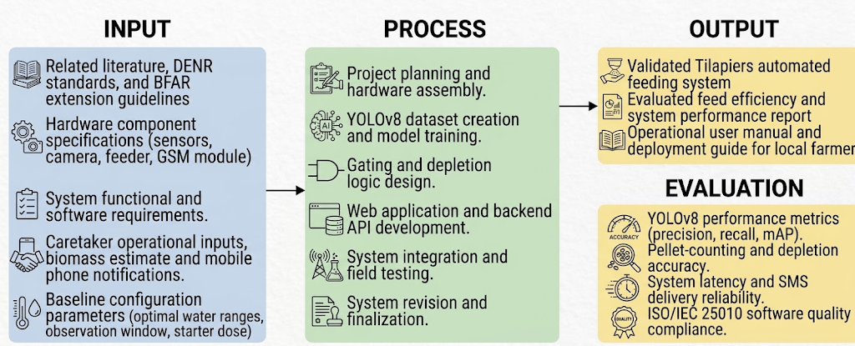

Figure 1 Research Paradigm
This figure illustrates the overall development methodology of the study, describing the major inputs required, the processes involved in designing and developing the system, and the expected outputs and evaluation methods. This framework serves as a guide for the entire research project, specifically to achieve the study's objectives.
The study’s input phase encompasses the foundational data and specifications required to build the system. This includes related literature, water quality standards from DENR Administrative Order No. 2016-08, and BFAR extension guidelines. It also includes hardware component specifications for the sensors, camera, feeder, and GSM module, as well as system functional and software requirements. Furthermore, caretaker operational inputs, such as the stocked biomass estimate and registered mobile phone number—are integrated with baseline configuration parameters (optimal water quality ranges, observation window duration, and reference starter dose) to establish operational boundaries.
The process phase covers the core execution steps involved in developing Tilapiers. These activities begin with project planning and physical hardware assembly, followed by the creation of a custom feed-pellet dataset and YOLOv8 model training. The software development pipeline includes designing environmental gating and depletion-responsive decision logic, as well as web application and backend API development.
Finally, the integrated hardware and software components undergo field testing at an outdoor facility, followed by iterative revisions and finalization. The output phase produces a validated Tilapiers automated feeding system, an evaluated feed efficiency and system performance report, and an operational user manual and deployment guide for local fish farmers. To verify that the system fulfills the research requirements, it undergoes an evaluation phase measuring YOLOv8 object detection performance metrics (precision, recall, mAP), pellet-counting and depletion accuracy, system latency, SMS delivery reliability, and ISO/IEC 25010 software quality compliance.

Conceptual Framework of the Proposed System
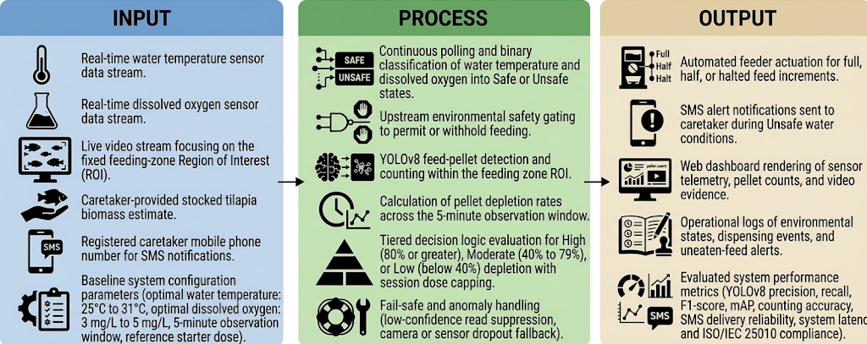

Figure 2 Conceptual Framework
This figure represents the overall conceptual framework of the study, illustrating the relationship between the system inputs, the processing of components, and the expected outputs. To elaborate, this framework maps how real-time environmental data and computer vision streams are processed through automated decision logic to execute precise feeding actions, alert caretakers, and render system telemetry.
The input layer consists of real-time sensor data streams for water temperature and dissolved oxygen, paired with a live video stream focusing on the fixed feeding-zone Region of Interest (ROI). It includes caretaker-provided operational parameters, specifically a stocked tilapia biomass estimate used to establish the reference starter dose and a registered mobile phone number for SMS notifications. These inputs operate within baseline system configuration parameters, including optimal water quality ranges of 25°C to 31°C for water temperature and at least 5 mg/L for dissolved oxygen, a 5-minute observation window, and the pre-calibrated reference starter dose.
The processing layer begins with continuous sensor polling and binary classification of temperature and dissolved oxygen into Safe or Unsafe states, acting as an upstream environmental safety gate that permits or withholds feeding. When permitted, the system engages a YOLOv8 object detection model to detect and count visible feed pellets within the ROI, calculating the pellet depletion rate across the 5-minute observation window. Tiered decision logic then evaluates this depletion rate as High (80% or greater), Moderate (40% to 79%), or Low (below 40%) to govern feed dispensing under a strict session dose ceiling. This layer also incorporates fail-safe and anomaly handling mechanisms to suppress low-confidence reads and manage camera or sensor dropouts.
The output layer encompasses the physical actions, web telemetry, operational records, and system evaluation results. Automated feeder actuation executes full, half, or halted feed increments based on the decision logic, while instant SMS alerts notify the caretaker during Unsafe water conditions. Simultaneously, the web dashboard renders real-time sensor telemetry, pellet counts, and video evidence, while maintaining operational logs of environmental states, dispensing events, and uneaten-feed alerts. Finally, the system yields benchmarked performance metrics, including YOLOv8 object detection performance (precision, recall, F1-score, mAP), pellet-counting accuracy, SMS delivery reliability, system latency, and ISO/IEC 25010 software quality compliance.

System Architecture
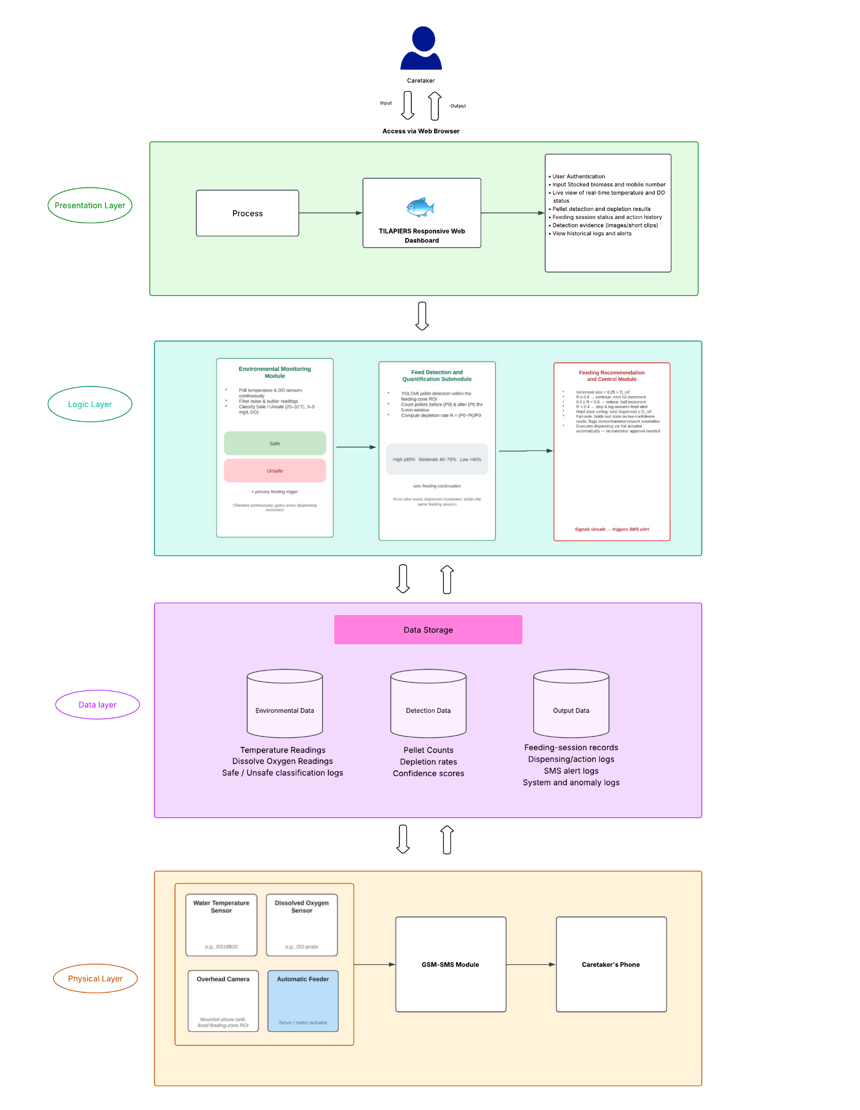

Figure 3 System Architecture

The Tilapiers system architecture is organized into four interconnected layers: the Presentation Layer, Logic Layer, Data Layer, and Physical Layer. The Presentation Layer serves as the caretaker-facing Web Interface through the Web-Based Dashboard and Alert Module, where the caretaker provides setup information such as the stocked biomass estimate and registered mobile number and views environmental status, pellet detection results, feeding-session history, and detection evidence through HTTPS API requests. The dashboard is updated in real time as new results are generated by the Logic Layer. The Logic Layer, hosted on the Application Server, serves as the operational core of the system and consists of three cooperating modules. First, the Environmental Monitoring Module continuously collects and filters temperature and dissolved-oxygen readings and determines whether the environment is Safe or Unsafe based on the study's baseline ranges of 25°C–31°C for temperature and at least 5 mg/L for dissolved oxygen. This environmental assessment serves as the primary feeding trigger. If either parameter is outside the acceptable range, the system classifies the environment as Unsafe, holds the feeding process, and signals the Alert Module to send an SMS notification to the registered caretaker. If both parameters are within the acceptable ranges, the environment is classified as Safe and the feeding process is permitted to proceed. The Feed Detection and Quantification Submodule then applies YOLOv8 to detect and count pellets within the feeding-zone region of interest immediately after dispensing (P₀) and again after a five-minute observation period (Pₜ), allowing the system to calculate the pellet depletion rate using R = (P₀−Pₜ)/P₀. The Feeding Recommendation and Control Module then evaluates the resulting depletion rate and determines the next feeding action. A High depletion rate (≥80%) results in the full next feeding increment, a Moderate depletion rate (40%–79%) results in a reduced feeding increment, and a Low depletion rate (<40%) results in stopping feeding for the session and logging the remaining pellets as an uneaten-feed alert. Feeding is dispensed in fixed increments of 0.25 × D_ref and remains subject to a strict session dose ceiling. The Logic Layer also implements fail-safe mechanisms, such as holding the current state when sensor or detection readings have low confidence and flagging detected anomalies for monitoring. The Data Layer, hosted on the Database Server, stores the information generated by the Logic Layer and retrieved by the Presentation Layer, including Environmental Data consisting of temperature and dissolved-oxygen readings and Safe/Unsafe history; Detection Data consisting of pellet counts, depletion rates, and confidence scores; and Output Data consisting of feeding-session records, dispensing and action logs, SMS alert logs, and system or anomaly logs. Finally, the Physical Layer consists of the field devices deployed at the tilapia pond or tank, including the water-temperature and dissolved-oxygen sensors, the overhead feeding-zone camera that provides visual data for pellet detection, the automatic feeder actuator that executes dispensing actions, and the GSM/SMS module that sends alerts directly to the caretaker's registered mobile number independently of the Web Interface. Together, these four layers enable Tilapiers to collect real-time environmental and feeding data, verify whether conditions are suitable for feeding, quantify pellet depletion, determine the appropriate feeding action, record system outputs, and provide the caretaker with real-time monitoring and SMS alerts.

System Flowchart
The system flowchart outlines the primary operational workflow of Tilapiers, beginning with user authentication and main menu navigation. It manages a continuous environmental monitoring pipeline that tracks water temperature and dissolved oxygen levels to verify whether water conditions meet optimal safety thresholds prior to scheduled feeding sessions. If parameters fall outside safe ranges, the system halts feeding and sends SMS alerts to caretakers. When conditions are optimal, the feeding module dispenses an initial starter dose and dynamically adjusts, reduces, or stops feed delivery based on observed fish appetite levels.
Beyond automated feeding and sensing, the architecture incorporates administrative management, system maintenance, and data security features. The profile management module handles user account authorization, staff archiving, and role assignments. System security is maintained through database backup and restoration routines, while an automated maintenance module dispatches routine SMS cleaning reminders to caretakers. Lastly, dedicated FAQ and system information modules provide operational guidance to support long-term usability.
All environmental readings, feeding logs, and administrative actions are systematically stored in a central database to maintain a complete operational history. This centralized data pipeline allows the web application to present real-time monitoring updates and issue automated SMS alerts to caretakers. Ultimately, the unified workflow connects continuous sensor gating with active user oversight to optimize feed usage and protect water quality.

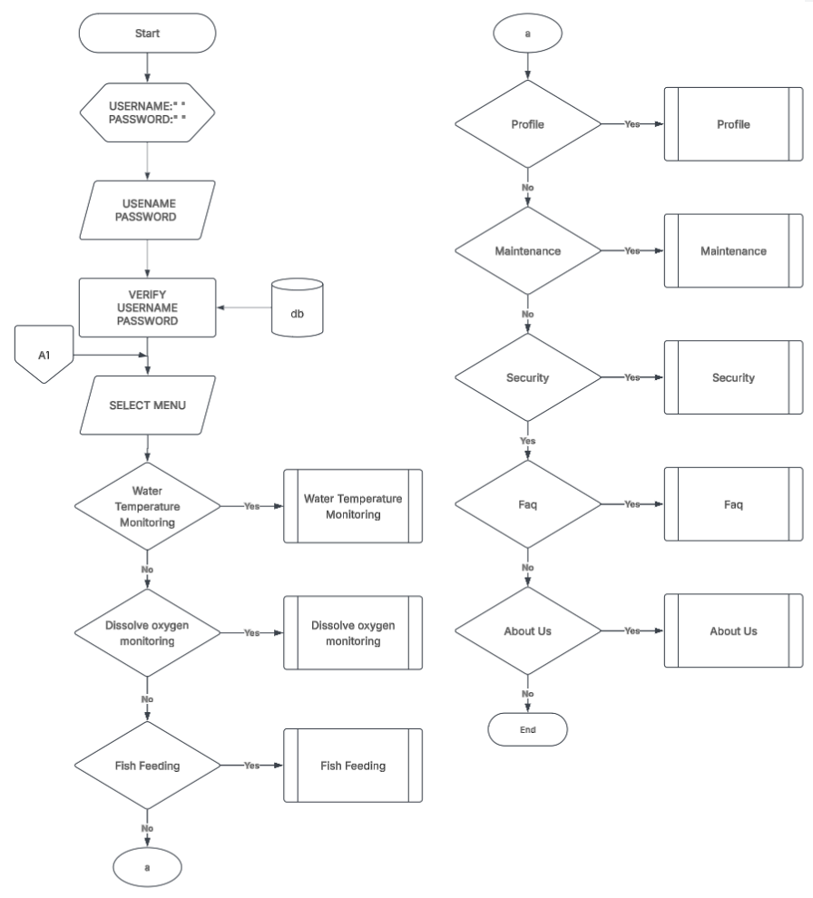

Figure 4 Main Menu Module
The main menu module authenticates user credentials against the database before granting access to primary system features. Upon successful verification, users can navigate to water parameter monitoring, fish feeding controls, user profile settings, system maintenance, security options, FAQs, or system information.
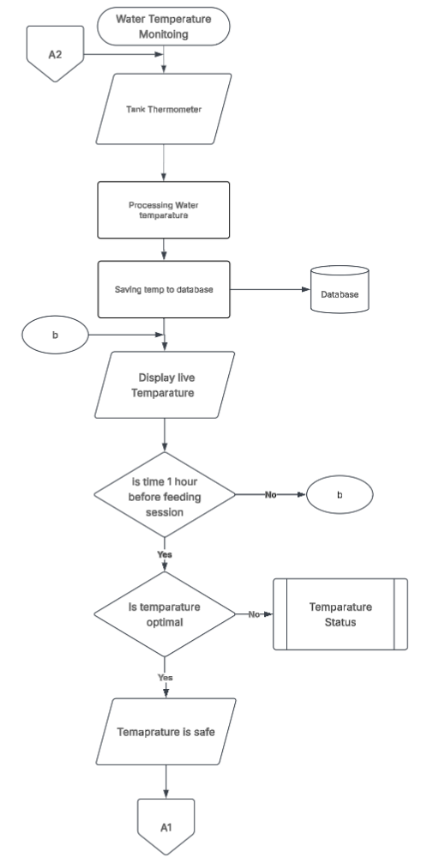

Figure 5 Water Temperature Monitoring Module
This module reads raw data from the tank thermometer, processes the values, and saves continuous temperature records to the database for live display. Exactly one hour before a scheduled feeding session, it evaluates whether the water temperature falls within optimal ranges before declaring the state safe or redirecting to status validation.

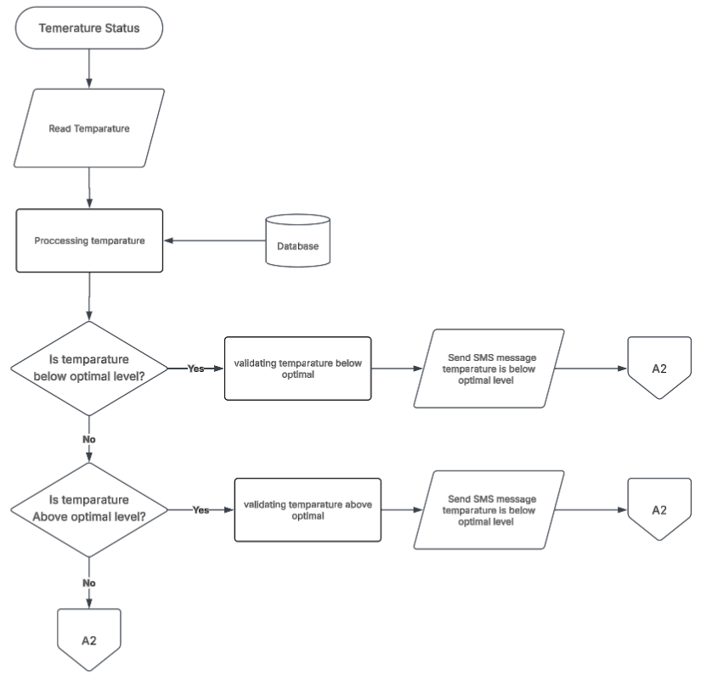

Figure 6 Temperature Status Module
The temperature status module checks stored water temperature data to determine whether readings have fallen below or risen above safe threshold levels. If an abnormal thermal state is detected, the system validates the reading and dispatches an automated SMS alert to notify caretakers of the sub-optimal condition.
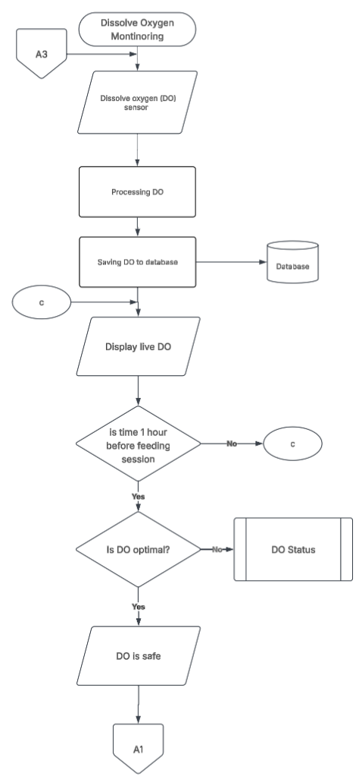

Figure 7 Dissolved Oxygen Monitoring Module
This module acquires dissolved oxygen levels from the tank sensor, processes the reading, and updates the central database to display live DO metrics. Prior to feeding, it assesses whether oxygen levels meet the required operational threshold and redirects the system to status handling if DO levels are inadequate.
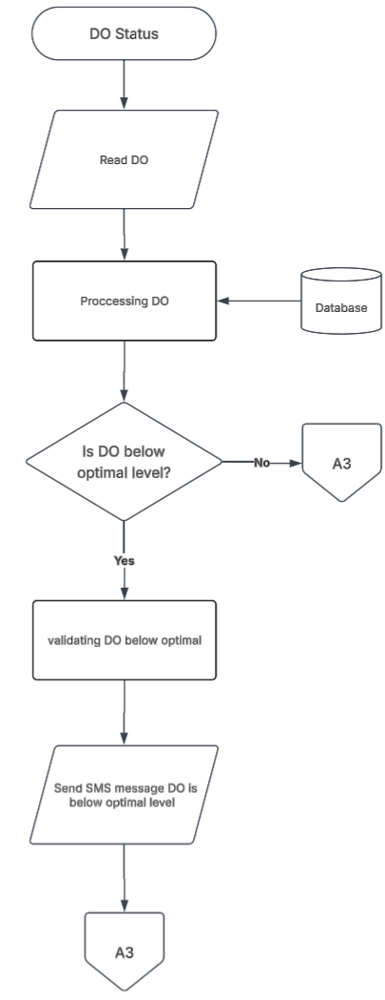

Figure 8 DO Status Module
The DO status module evaluates oxygen measurements against optimal biological requirements to identify hypoxic or unsafe conditions. When dissolved oxygen falls below the required threshold, the system validates the alert and immediately transmits an SMS warning to the caretaker.
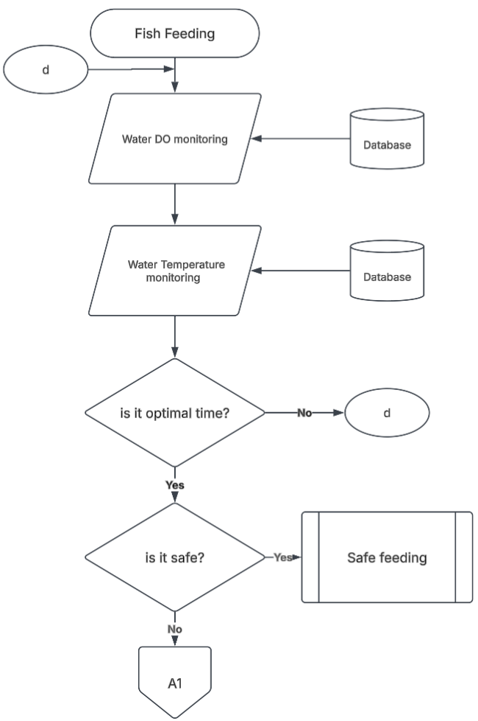

Figure 9 Fish Feeding Evaluation Module
This module retrieves water temperature and dissolved oxygen data from the database to check if environmental conditions and scheduled feeding times align. If both environmental gating checks pass successfully, the workflow proceeds to execution, whereas unsafe conditions halt the feeding sequence and return to the main menu.

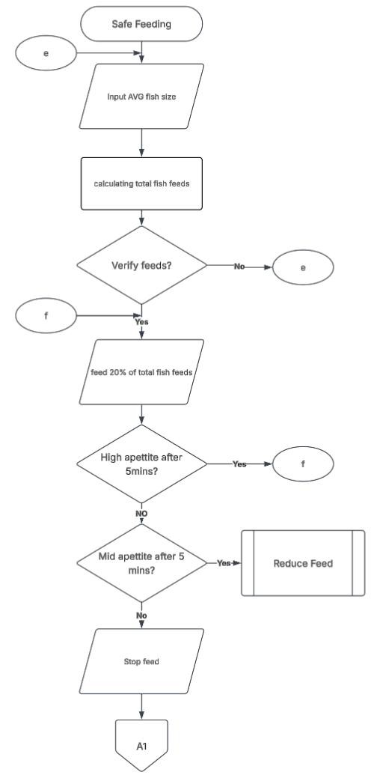

Figure 10 Safe Feeding Execution Module
Once safe feeding is confirmed, the system calculates total feed requirements based on average fish size and dispenses an initial 20% starter ration. It monitors fish appetite over five-minute intervals, continuing incremental feeding for high appetite, triggering feed reduction for moderate appetite, or stopping feed if no activity is observed.
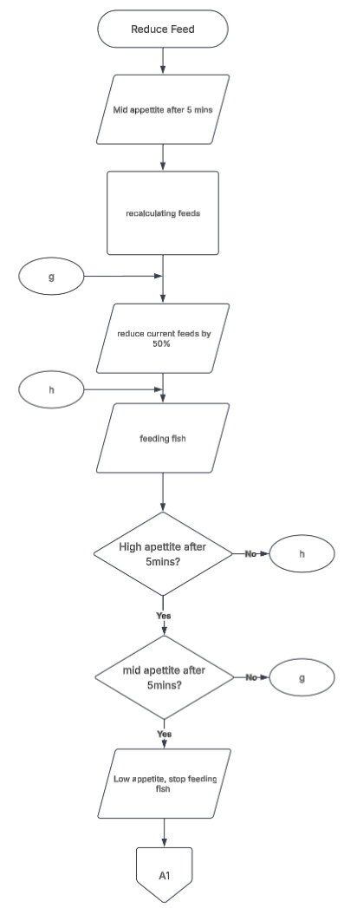

Figure 11 Reduce Feed Module
The reduce feed module recalculates remaining feed quantities and cuts the active ration by 50% when moderate fish appetite is observed. It re-evaluates fish feeding behavior after five minutes to either adjust dosing further or completely terminate feeding if consumption drops.
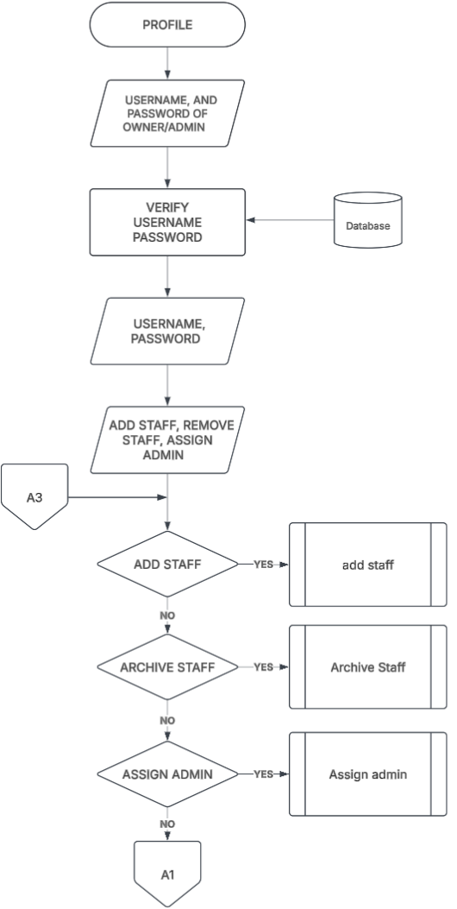

Figure 12 Profile Management Module
The profile module verifies administrator login credentials to authorize system management tasks. Once authenticated, administrators can choose to add new staff accounts, archive existing employee profiles, or reassign admin privileges.
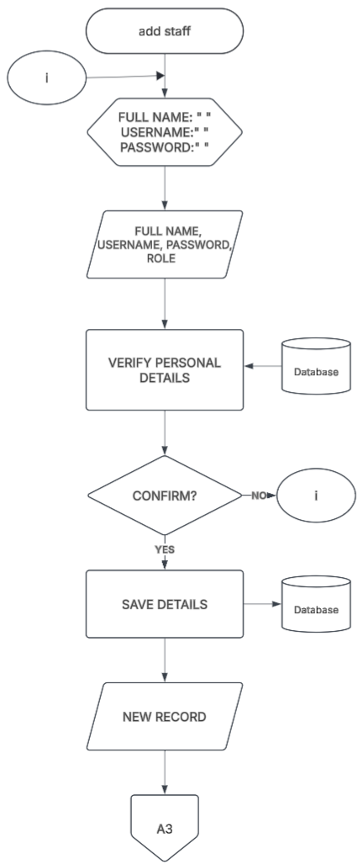

Figure 13 Add Staff Module
This module collects full name, username, password, and assigned role for new system users and verifies these personal details against the database. Upon confirmation, the new account details are saved to the database, generating a new user record for system access.
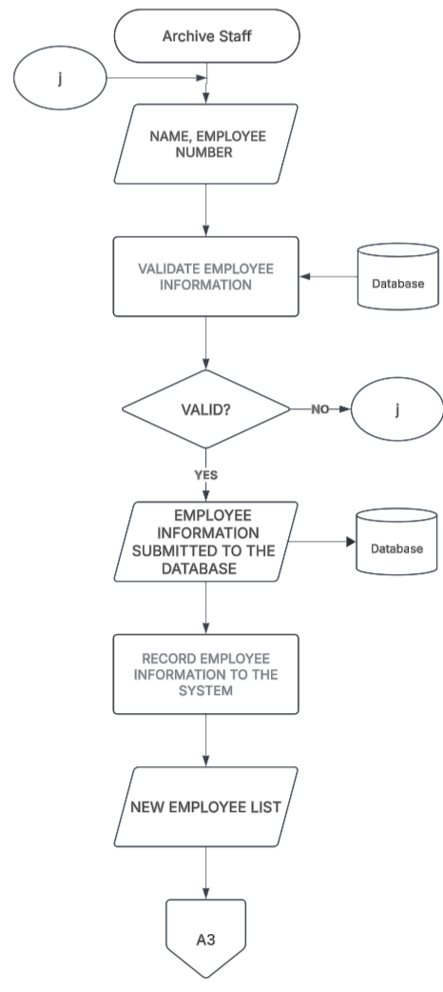

Figure 14 Archive Staff Module
The archive staff module processes employee identification details and validates them against current database records. Once validated, the selected employee profile is archived and saved in the system to maintain an updated active staff list.
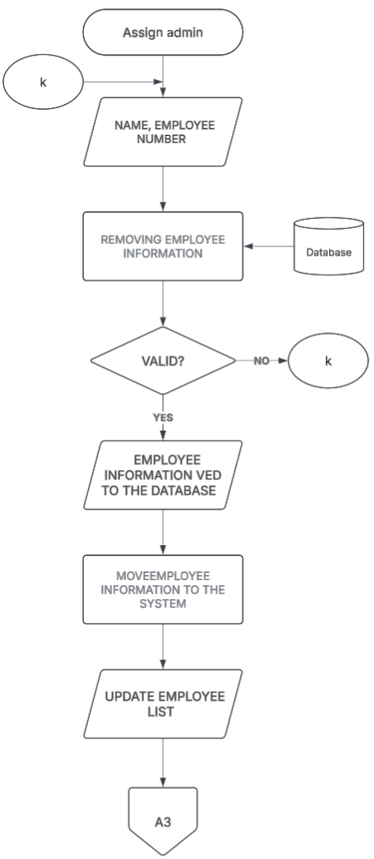

Figure 15 Assign Admin Module
This module prompts for employee information to modify system administrative roles within the central database. After validating the user details, it updates user permission levels and saves the revised administration list.
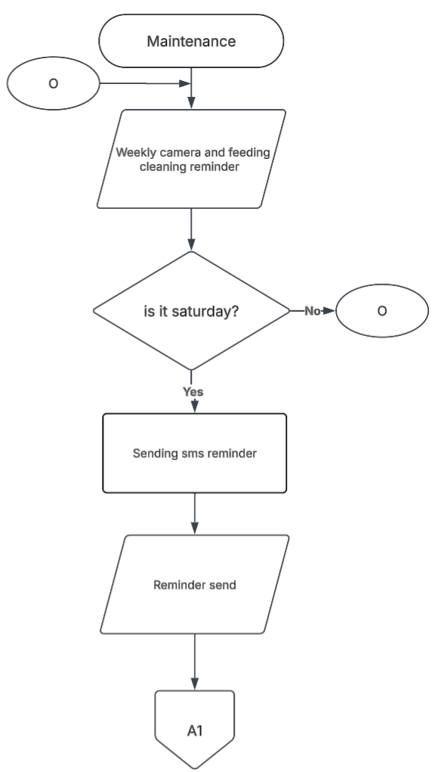

Figure 16 Maintenance Module
The maintenance module manages routine physical upkeep by evaluating weekly operational schedules for cleaning cameras and feeding hardware. On designated Saturdays, the system automatically triggers and transmits an SMS maintenance reminder to system operators.
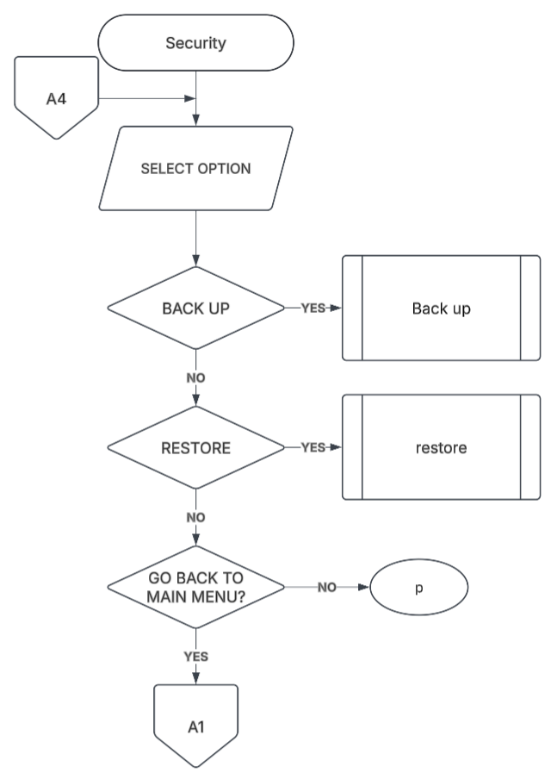

Figure 17 Security Module
The security module provides administrators with menu options to execute system data backups, restore prior database states, or return to the main navigation menu. It routes user selections to dedicated backup and restoration sub-processes to safeguard critical operational logs.
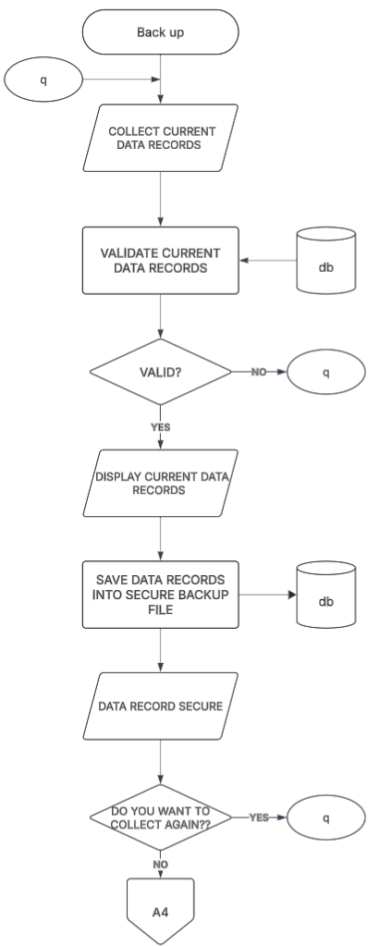

Figure 18 Backup Module
The backup module aggregates current data logs, validates database records, and renders them on screen for user review. Verified records are compiled into a secure backup file in the database, with an option to repeat data collection or exit back to the security menu.
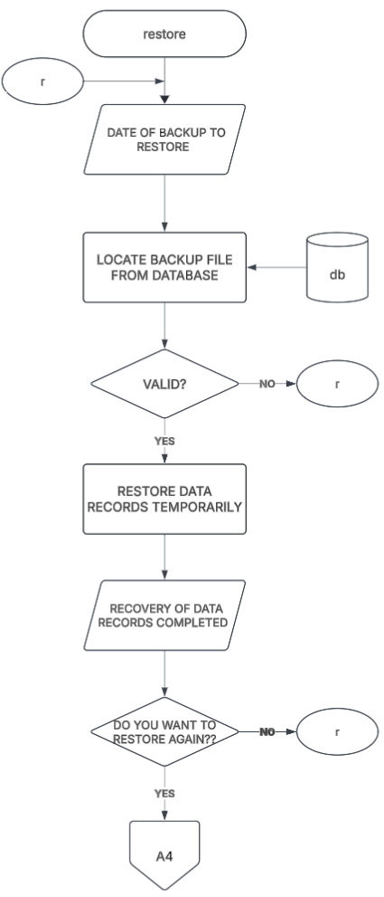

Figure 19 Restore Module
This module allows administrators to select a specific backup date and locates the corresponding archive file within the database. Once validated, it temporarily restores data records and completes system recovery before prompting the user to finish or repeat the process.
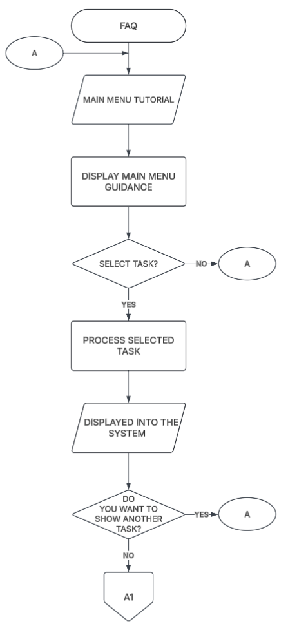

Figure 20 FAQ Module
The FAQ module displays interactive guidance and tutorials covering the operation of various system menu tasks. Users can select specific tasks to process instructional guidance on screen with the option to view additional operational tutorials.
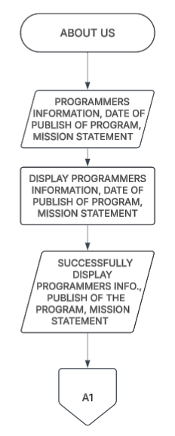

Figure 21 About Us Module
The About Us module retrieves programmer information, program publication dates, and system mission statements. It renders these details clearly on the screen before returning the user to the main menu routing interface.

Definition of Terms
To provide clarity and better understanding of the concepts used in this study, the following terms are defined operationally as they are applied within the context of the research:
Terms | Definition
Actuator | The mechanism that physically dispenses feed into the tank as soon as the feeding decision algorithm determines an action, without requiring caretaker approval for each increment.
Aquaculture | The farming of aquatic organisms such as fish under controlled conditions, applied in this study to the culture of Nile tilapia in a small-scale outdoor tank setup.
Average Body Weight (ABW) | The mean weight of the stocked tilapia, expressed in grams, used to identify the culture stage (36–99 g for starter, 127–221.5 g for grower, and 256.5–361.5 g for finisher) and to compute the fixed reference starter dose.
BFAR-NCR | The Bureau of Fisheries and Aquatic Resources – National Capital Region, whose Fisheries Production Section provided the field consultation, extension feeding guidelines, and testing facility that informed the study’s operational thresholds and feeding practice.
Biomass | The approximate total weight of the tilapia stocked in the tank, entered manually by the caretaker at setup and used with the feeding rate and feeding frequency to compute the fixed reference starter dose.
Biometric Estimation | The measurement of individual fish characteristics such as size or weight, usually from camera images, which other systems use to compute feed quantity. Tilapiers does not perform this task.
Camera Module | The fixed camera that captures real-time video of the feeding zone, serving as the image source for feed-pellet detection and counting.
Caretaker | The authorized person responsible for the tank who performs the initial system setup, receives SMS alerts on a registered mobile number, and reviews feeding activity and alerts through the web dashboard.
Closed-Loop Feeding | A feeding control approach in which each feeding action depends on the observed result of the previous one, specifically the pellet-depletion rate measured after each dispensed increment, rather than on a fixed schedule alone.
Computer Vision | A field of artificial intelligence that enables machines to interpret digital images and video, applied in this study to detect and count feed pellets within the feeding zone in real time.
Confidence Threshold | The minimum detection-confidence value a prediction must reach to be used in the feeding decision; readings below it are suppressed and flagged as low-confidence.
Culture Stage | The growth phase of the tilapia covered by the system, namely the starter (month 2), grower (month 3), and finisher (month 4) stages, each with its own pellet size, feeding rate, and feeding frequency. The fry stage (month 1) is outside the study’s scope.
Dashboard (Web Dashboard) | The web-based interface through which the caretaker views real-time environmental readings, pellet counts, feeding-session status, uneaten-feed alerts, SMS logs, and the detection evidence (pellet count and a frame or short clip) behind each dispensed increment.
Data Augmentation | A technique that artificially varies training images to improve the detection model’s robustness to lighting and water-clarity conditions.
Deep Learning | A subfield of machine learning that uses multi-layer neural networks to learn features directly from data, serving as the basis of the YOLO models used in this study.
DENR Administrative Order No. 2016-08 | The Department of Environment and Natural Resources order on water quality guidelines and general effluent standards, used in this study as a reference for the optimal temperature and dissolved-oxygen standards of Class C freshwater intended for the propagation and growth of fishery species.
Depletion Classification | The categorization of the depletion rate into three tiers that determine the next feeding action: High depletion (R ≥ 0.8), which continues the next full increment; Moderate depletion (0.4 ≤ R < 0.8), which reduces the next increment by half; and Low depletion (R < 0.4), which stops the session.
Depletion Rate (R) | The proportion of feed pellets that disappear from the feeding zone during the observation window, computed as R = (P0 − Pt) / P0, where P0 is the pellet count after an increment is dispensed and Pt is the pellet count at the end of the window.
Depletion-Responsive Feeding Decision Algorithm | The deterministic, rule-based algorithm that releases the fixed reference starter dose in fixed-size increments and decides whether feeding continues, is reduced, or is stopped based on the pellet-depletion rate observed during the observation window.
Dissolved Oxygen (DO) | The amount of oxygen dissolved in the tank water, measured in milligrams per liter (mg/L), which governs the fish’s respiration. In this study, a DO of at least 5 mg/L is the minimum level at which feeding is permitted.
Environmental Verification Gate | The binary safety check that reads water temperature and dissolved oxygen and permits feeding only when both are within their optimal ranges; otherwise feeding is withheld and an SMS alert is sent to the caretaker.
F1-score | The harmonic mean of precision and recall, used as a single measure of the detection model’s performance.
Fail-Safe Handling | The protective measures that limit the impact of false, missing, or noisy data, including the session dose ceiling, suppression of low-confidence detections, flagging of implausibly rapid depletion for caretaker review, and defaulting to no feeding action when a sensor reading, camera feed, or network connection fails.
Feed Pellet | A floating extruded feed particle (Tateh ExtruFloat Premium) sized to the culture stage (2.8–3.2 mm for starter, 3.3–3.7 mm for grower, and 3.8–4.3 mm for finisher), which is the object detected and counted by the system.
Feeding Frequency | The number of feeding sessions per day for a given culture stage: four times a day for the starter stage, three for the grower stage, and two for the finisher stage.
Feeding Rate | The daily amount of feed expressed as a percentage of the stocked biomass: 5% for the starter stage, 3% for the grower stage, and 2% for the finisher stage, per BFAR-NCR extension feeding guidelines.
Feeding Zone | The area of the tank where feed pellets are dispensed and observed by the camera, which serves as the direct observable indicator of whether a feeding session should continue.
Fixed Reference Starter Dose (D_ref) | The per-session portion of the daily ration, computed from the stage-specific feeding rate applied to the stocked biomass and divided by the stage-specific feeding frequency. It is calibrated at stocking and serves as the hard ceiling for each session.
Fixed-Size Increment | A small portion of feed equal to 25% of the reference starter dose (0.25 × D_ref), released one at a time so that pellet depletion can be observed before the next portion is dispensed.
Ground Truth | The manually verified pellet counts and depletion values against which the system’s outputs are compared during evaluation.
Hypoxic Stress | The physiological stress fish experience when dissolved oxygen is too low, which can cause oxidative stress and other physiological harm and is one reason low DO makes feeding unsafe.
Internet of Things (IoT) | A network of interconnected sensors, devices, and communication modules that collect and exchange data, applied in this study to monitor water temperature and dissolved oxygen and to automate feeding.
ISO/IEC 25010 | The international software product quality model used in this study to evaluate the software quality of the system.
Mean Average Precision (mAP) | A metric that summarizes the detection model’s performance across confidence thresholds by averaging the Average Precision over the detected classes.
Nile Tilapia (Oreochromis niloticus) | A widely cultivated freshwater fish known for its rapid growth, environmental tolerance, and market demand, and the sole species used in this study.
Object Detection | A computer vision task that identifies the presence of specific objects in an image and locates them, applied in this study to detect and count individual feed pellets.
Observation Window | The five-minute interval after each dispensed increment during which the feeding zone is monitored to measure pellet depletion, based on the 3–5-minute observation period described in the BFAR-NCR field consultation.
Overfeeding | The dispensing of more feed than the fish consume, causing uneaten feed to sink and decompose, which promotes bacterial loading and degrades water quality.
Pellet Count | The number of feed pellets detected within the feeding zone by the YOLOv8-based model, taken after an increment is dispensed (P0) and at the end of the observation window (Pt).
Pellet-Counting Accuracy | A performance measure of how closely the number of pellets counted by the system matches the manually verified number of pellets.
Pilot Calibration | The process of confirming and adjusting the study’s initial threshold values, such as the temperature and dissolved-oxygen bands, depletion-rate cut-offs, and observation window, through trial operation at the tank setup.
Poikilothermic | Describing organisms, such as Nile tilapia, that cannot regulate their own body temperature, so that their metabolism, digestion, and appetite depend on the temperature of the surrounding water.
Precision | A metric indicating how many of the objects the model identifies as feed pellets are actually pellets.
Precision Aquaculture | The use of sensing, data analysis, and automation to manage fish farming based on real-time information rather than manual, experience-based judgment.
Recall | A metric indicating how many of the actual feed pellets in the feeding zone are successfully detected by the model.
Recommendation-to-Execution Latency | The time between the moment the decision algorithm determines a feeding action and the moment the actuator executes it.
Region of Interest (ROI) | The defined portion of the camera frame covering the feeding zone, within which the model detects and counts feed pellets.
Safe | The environmental state in which water temperature is within 25°C to 31°C and dissolved oxygen is at least 5 mg/L simultaneously, allowing incremental feeding to begin.
Sensors (Water Temperature and Dissolved Oxygen) | The hardware components that continuously measure the two environmental parameters used by the verification gate, each to be validated against reference instruments during system development.
Session Dose Ceiling | The hard limit that prevents the total feed dispensed in a session from exceeding the fixed reference starter dose, regardless of how many increments are released or how consistently high depletion is reported.
SMS Alert | An automated text message sent to the caretaker’s registered mobile number when the environment is classified as Unsafe.
SMS/GSM Module | The hardware component that connects to the cellular network to send SMS alerts to the caretaker.
System Telemetry | The environmental readings, pellet counts, feeding-session depletion status, uneaten-feed alerts, SMS alert logs, low-confidence and anomaly flags, and dispensing execution logs made available to the caretaker through the web dashboard.
Tilapiers | The proposed web-based, temperature- and dissolved-oxygen-aware tank monitoring and automated feeding system that combines an environmental verification gate, YOLOv8-based feed-pellet detection, and a depletion-responsive feeding decision algorithm for Nile tilapia at the starter, grower, and finisher stages.
Uneaten-Feed Alert | A notification logged when depletion is classified as Low, flagging the remaining pellets in the feeding zone as a water-quality risk.
Unsafe | The environmental state in which temperature is below 25°C or above 31°C, or dissolved oxygen is below 5 mg/L, causing feeding to be withheld entirely and an SMS alert to be sent to the caretaker.
Visible Feed-Pellet Depletion | The decline in the number of feed pellets visible within the feeding zone over the observation window, used in this study as a proxy for consumption rather than direct proof of ingestion.
Water Temperature | The temperature of the tank water, which directly influences the tilapia’s metabolism and appetite. The Safe range in this study is 25°C to 31°C.
YOLOv8 | A single-stage deep learning object detection model (You Only Look Once, version 8) trained on the study’s own feed-pellet images to detect and count pellets in real time.

Table 5 Definition of Terms

CHAPTER 3

Research Methodology
This chapter presents the research methodology and operational framework used in the design, development, and evaluation of Tilapiers, the environment-gated, depletion-responsive automated feeding system for Nile tilapia at the starter, grower, and finisher stages (months 2 to 4 of culture) introduced in Chapter 1. As the study is classified as technical developmental research, this chapter is organized around the five methodological components prescribed for this research type: Project Design, Project Development, Testing and Operating Procedure, Project Evaluation, and Work Plan. Consistent with the requirement that computing standards and modern tools and techniques be integrated throughout the methodology rather than treated as an isolated topic, each section identifies the specific standards, frameworks, and development tools applied at that stage of the project. The chapter closes with a discussion of the system's potential for commercialization, covering its market model, measurable benefits, three-year product roadmap, go-to-market strategy, and business model.

Research Design
This study follows a technical developmental research design, appropriate for projects whose primary output is a working hardware-software system rather than a statistically generalizable conclusion drawn from a sampled population. Development is structured by the V-model described under Project Development, which pairs every development stage with a corresponding level of testing. Within that structure, the environmental gating logic, the YOLOv8 detection pipeline, the feeding decision algorithm, and the web dashboard are each built, tested, and refined across successive short cycles under an Iterative and Incremental Development (IID) approach rather than in a single linear pass. This combination was selected over a strict Waterfall approach because Tilapiers integrates hardware calibration, a trained computer vision model, and control software whose parameters (e.g., detection-confidence thresholds, depletion-rate cut-offs, and the observation window) cannot be finalized analytically and instead require empirical tuning against pilot data, as anticipated by the pilot calibration described in Chapter 1. This pattern of iterative refinement is more compatible with incremental delivery and short feedback loops than with a design that treats requirements as fixed from the outset, while the V-model ensures that the test criteria for each stage are defined before implementation begins.
The physical build of the system additionally follows the standard engineering design process (problem definition, requirement specification, conceptual design, detailed design, prototyping, testing, and iteration) to co-develop the sensor, actuator, and camera subsystems alongside the software modules. Agile-inspired sprint planning (two-week iterations, sprint backlogs, and end-of-sprint review) is used to sequence coding tasks across both hardware and software workstreams within the Coding stage of the V-model.
Unit of Analysis. The unit of analysis is the Tilapiers system as an integrated hardware-software prototype, specifically its performance on the technical benchmarks defined in Chapter 1, Objective 5 (object detection performance reported overall and per class, pellet-counting and depletion accuracy, environmental classification accuracy, SMS delivery reliability, and recommendation-to-execution latency) and its software quality as assessed under ISO/IEC 25010 through both objective testing and the evaluator instrument described under Project Evaluation. This is distinct from a social-science unit of analysis such as an individual respondent; here, the respondents are evaluators of a single system under test, not independent subjects being compared to one another.
Study Setting and Test Materials. In line with the scope in Chapter 1, the system is developed and tested in a small-scale outdoor tank measuring 81 cm × 109 cm with a depth of 72 cm, using 20 Nile tilapia supplied by BFAR at the starter, grower, and finisher stages (approximately the second, third, and fourth months of culture), at a BFAR-provided facility. Feeding uses Tateh ExtruFloat Premium floating extruded feed, with the pellet size matched to each culture stage (2.8–3.2 mm for starter, 3.3–3.7 mm for grower, and 3.8–4.3 mm for finisher; Table 1, Chapter 1). Stage-specific average body weights, daily feeding rates, and feeding frequencies follow Table 1 of Chapter 1.
Subjects and Sample Size. Because this is a developmental study evaluated through expert and end-user judgment rather than a population survey, subjects were selected through purposive sampling rather than probability sampling. A total of thirty (30) evaluators are targeted, distributed across three respondent groups of ten (10) each: (1) IT/software engineering experts competent to assess software quality characteristics under ISO/IEC 25010; (2) aquaculture technical personnel, including BFAR-NCR Fisheries Production Section staff, competent to assess the system's alignment with field feeding practice and water-quality standards; and (3) prospective end users, namely small-scale tilapia farmers and hobbyists, competent to assess the system's usability and practical value. This tri-group composition is intended to triangulate technical soundness, domain fidelity, and practical usability, consistent with the study's Significance section in Chapter 1.

Project Design
Project design specifies the concrete hardware and software features implementing the operational modules defined in the system flowchart (Chapter 2, Figures 4–21) within the four-layer system architecture (Chapter 2, Figure 3): the Presentation Layer (web dashboard), the Logic Layer (application server), the Data Layer (database server), and the Physical Layer (sensors, camera, feeder actuator, and GSM/SMS module). Unlike the five broad modules used to describe the system at a high level in Chapter 2 (environmental monitoring, feed detection and quantification, feeding recommendation and control, web-based dashboard and alert, and maintenance and logging), Table 6 below reflects the actual module decomposition shown in the flowchart, including the navigation, environmental-status, feeding, and administrative modules the caretaker interacts with directly. The YOLOv8-based pellet-detection and depletion-responsive dosing logic reviewed in Chapter 2 is retained as the underlying decision engine and is implemented within the Safe Feeding Execution and Reduce Feed modules described below.

Module | Hardware / Software Components | Design Basis and Standards
Main Menu and Authentication Module | Web front-end login screen; backend credential-verification service; session management. | Standard username/password authentication against the relational database; access gating and routing for all downstream modules (water temperature monitoring, dissolved oxygen monitoring, fish feeding, profile management, maintenance, security, FAQ, and About Us).
Water Temperature Monitoring Module | Waterproof digital temperature probe (tank thermometer); MCU for polling and pre-filtering; live-display dashboard component. | Continuous polling and live logging; evaluation exactly one hour before each scheduled feeding session; Safe band of 25 °C to 31 °C per Table 2 of Chapter 1, informed by DENR AO 2016-08 Class C freshwater standards and the BFAR-NCR field consultation.
Temperature Status Module | Backend validation logic; SIM800L-class GSM/SMS module. | Determines whether the stored reading is below or above the optimal band; triggers an SMS alert to the caretaker's registered number on an abnormal thermal reading.
Dissolved Oxygen Monitoring Module | Galvanic or optical DO sensor; MCU for polling and pre-filtering; live-display dashboard component. | Continuous polling and live logging; evaluation one hour before each scheduled session; DO threshold of at least 5 mg/L as the minimum feeding threshold, per the BFAR-NCR consultation, DENR AO 2016-08, and pilot calibration.
DO Status Module | Backend validation logic; SIM800L-class GSM/SMS module. | Flags below-optimal DO readings against the calibrated threshold; triggers an SMS alert on a hypoxic or unsafe reading.
Fish Feeding Evaluation Module | Server-side gating logic reading the latest stored temperature and DO classifications and the scheduled feeding time. | Deterministic rule-based gate: feeding proceeds only when both the Temperature Status and DO Status checks return Safe and the scheduled time aligns; otherwise the session is halted, logged, and control returns to the main menu.
Safe Feeding Execution Module | Overhead fixed-position camera aimed at the feeding-zone ROI; single-board/edge-AI unit running the selected YOLOv8 variant (Ultralytics framework, PyTorch backend); actuator (auger- or servo-driven feeder) triggered via relay/GPIO. | Model architecture per Jocher et al. (2023); pellet-centered detection approach adapted from Riyandani et al. (2023), trained on four classes (tilapia, feed pellets, air bubbles, and fish waste). Retrieves the fixed reference starter dose (D_ref) for the current culture stage and dispenses it in fixed increments of 0.25 × D_ref, computing the pellet-depletion rate R = (P0 − Pt)/P0 over the 5-minute observation window and classifying it High/Moderate/Low (Table 3, Chapter 1). Total dispensed feed never exceeds D_ref.
Reduce Feed Module | Shares the Safe Feeding Execution Module's camera/YOLOv8 pipeline and actuator. | Triggered when depletion is classified Moderate; cuts the next increment to 50% of the fixed increment size and re-evaluates depletion after the next 5-minute window to restore the full increment, continue at the reduced size, or terminate feeding, per the same tiered logic.
Web-Based Dashboard and Alert Sub-layer | Front-end single-page application; backend REST/WebSocket API; shared across all monitoring and feeding modules. | Responsive UI design; real-time telemetry via MQTT; renders environmental status, pellet counts and the corresponding frame or short clip for each dispensed increment, feeding-session status, uneaten-feed alerts, and SMS logs.
Profile Management Module | Admin authentication check; staff-record CRUD operations (Add Staff, Archive Staff, Assign Admin sub-modules) against the relational database. | Role-based access control for administrative functions; changes logged for auditability.
Maintenance Module | Scheduled task runner; SIM800L-class GSM/SMS module. | Weekly (Saturday) automated SMS reminder for camera and feeder cleaning, independent of the feeding decision logic.
Security Module | Backup and Restore sub-modules operating on the relational database. | Scheduled and on-demand backup of environmental, feeding, and administrative records, and restoration of a prior database state selected by backup date.
FAQ Module | Static/semi-static content rendering from the database. | Interactive tutorials and operational guidance for each main-menu task; no interaction with sensor or feeding logic.
About Us Module | Static/semi-static content rendering from the database. | Displays programmer information, the program's publication date, and the system's mission statement; no interaction with sensor or feeding logic.

Table 6 System Features and Design Basis by Operational Module

Computing Standards, Modern Tools, and Techniques
Consistent with the requirement to integrate computing standards and modern development tools and techniques throughout the operational framework, Table 7 consolidates the standards, frameworks, and tools applied across the project, indicating the methodological stage at which each is used. Later sections reference this table rather than restating each standard in full.
Standard / Tool / Technique | Applied In | Purpose
ISO/IEC 25010:2011 (Software Product Quality Model) | Acceptance Testing; Testing Strategy; Project Evaluation | Defines the eight quality characteristics (functional suitability, performance efficiency, compatibility, usability, reliability, security, maintainability, portability) used to structure both non-functional testing and the expert/end-user evaluation instrument. Functional suitability, performance efficiency, and reliability are the characteristics named in Chapter 1, Statement of the Problem 5.
ISO/IEC/IEEE 29148 (Requirements Engineering) | Requirement Gathering; System Analysis | Structures the software/hardware requirements specification (SRS) produced during requirements gathering with BFAR-NCR.
ISO/IEC/IEEE 29119 (Software Testing) | Unit, Integration, System, and Acceptance Testing | Provides the vocabulary and process structure for the four test levels.
DENR Administrative Order No. 2016-08 | Requirement Gathering; System Analysis; pilot calibration | Reference water-quality standard for Class C freshwater used to bound the Safe/Unsafe classification bands.
V-model | Project Development (overall) | Pairs each development stage with a test level so that test criteria are defined before implementation and defects are traceable to the originating stage.
Agile/Scrum (two-week sprints) | Coding | Iterative delivery cadence for both hardware assembly and software increments; sprint backlog and review cycle.
Git / GitHub (version control) | Coding | Source-code management, branching, and collaborative review across the four-member development team.
Roboflow / LabelImg (dataset annotation) | Coding (dataset preparation) | Bounding-box annotation of images of tilapia, feed pellets, air bubbles, and fish waste for YOLOv8 training; dataset versioning and augmentation.
Ultralytics YOLOv8 framework (PyTorch) | Coding (model training); Unit Testing | Transfer learning and fine-tuning of the pellet-detection model; export to an inference-optimized format for edge deployment.
RESTful API design (OpenAPI 3.0) | Module Design; Coding | Standardized, documented contract between the decision engine, dashboard, and actuator firmware.
MQTT protocol | Module Design; Coding | Lightweight publish-subscribe messaging for real-time sensor telemetry to the dashboard.
Docker containerization | Coding; Final Deployment | Environment consistency between development machines and the field-deployed backend.
CI/CD pipeline (GitHub Actions) | Unit and Integration Testing; pre-deployment | Automated build, lint, and regression-test execution on every code change prior to field deployment.

Table 7 Computing Standards, Tools, and Techniques Applied Across the Methodology

Project Development
The researchers will adopt the V-model as the development methodology for Tilapiers. The system combines hardware sensing and actuation, a computer vision model, a rule-based feeding decision algorithm, and a web application, and its behavior directly affects the fish (feeding permission, dose ceiling, and fail-safe responses). A model that pairs every development stage with a corresponding level of testing allows the test criteria for each stage to be defined before implementation begins and ensures that each requirement and design decision is verified and validated. As illustrated in Figure 22, the left arm of the V covers the development stages (requirement gathering, system analysis, software design, module design, and coding), while the right arm covers the corresponding testing levels (unit testing, integration testing, system testing, and acceptance testing). Each design stage is linked to the testing level that verifies it, and the process concludes with final deployment. Table 8 summarizes these correspondences.
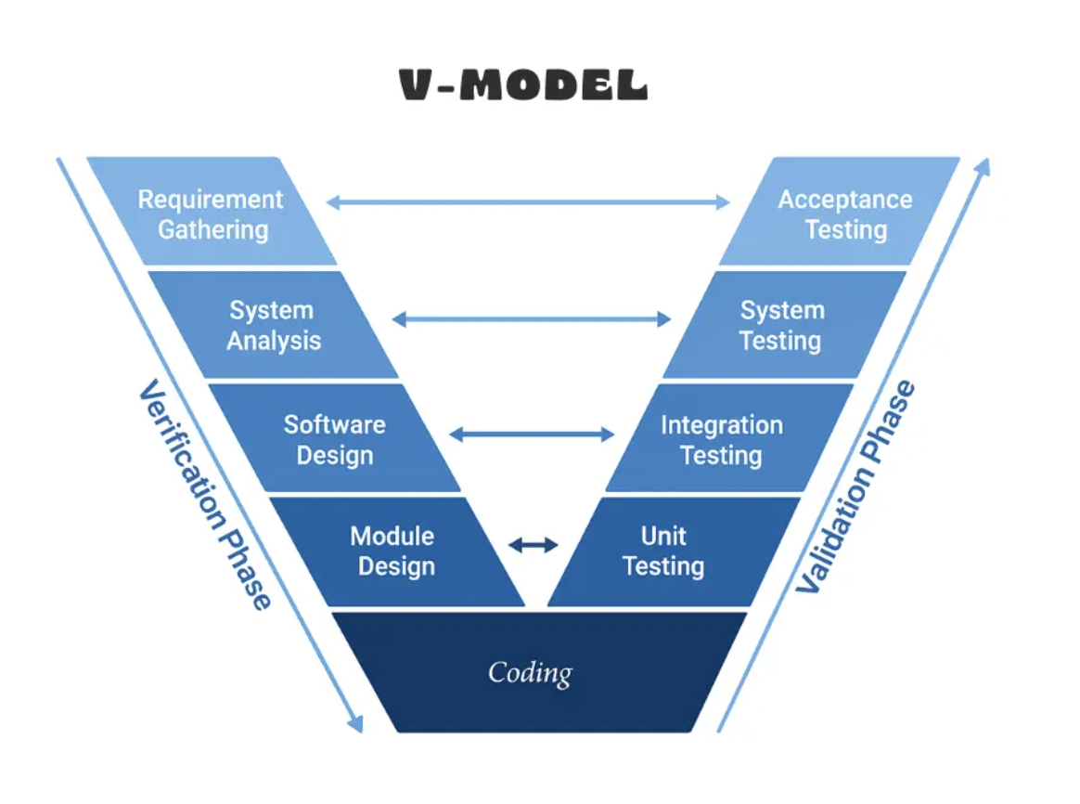

Figure 22 V-Model Diagram

Development stage | Verified by | Test basis prepared alongside the stage
Requirement Gathering; System Analysis | Acceptance Testing | Acceptance criteria defined at System Analysis from the stakeholder, BFAR-NCR, and DENR AO 2016-08 requirements and the Chapter 1 objectives.
Software Design | System Testing | End-to-end scenarios covering the gate, incremental dispensing, tiered depletion response, session dose ceiling, SMS alerting, dashboard presentation, and simulated fault conditions.
Module Design | Integration Testing | Interface and data-flow cases among the sensors, microcontroller, vision unit, decision algorithm, actuator, SMS module, and web application.
Coding | Unit Testing | Per-function assertions and component checks, including boundary cases for the thresholds, depletion tiers, and stage classification.

Table 8 Correspondence Between V-Model Development Stages and Test Levels

Requirement Gathering
In the requirement gathering stage, the researchers will consult stakeholders and reference sources to collect the raw requirements of the Tilapiers system, following the requirements structure of ISO/IEC/IEEE 29148. This includes identifying the target species and growth stages (Nile tilapia at the starter, grower, and finisher stages, approximately months 2 to 4 of culture), the outdoor tank setup at the BFAR-provided facility, the feed product and its stage-specific pellet sizes (Tateh ExtruFloat Premium), the stage-specific average body weight, feeding rate, and feeding frequency (Table 1, Chapter 1), the applicable threshold sources (peer-reviewed literature, the BFAR-NCR field consultation, and DENR Administrative Order No. 2016-08), and the hardware requirements (water-temperature sensor, dissolved-oxygen sensor, overhead camera module, microcontroller, computer vision processing unit, automatic feeder actuator, and SMS/GSM module) and software requirements (web application, backend API, database, and dashboard) needed to meet stakeholder needs.

System Analysis
In the system analysis stage, the researchers will analyze the gathered requirements to define the system-level specifications of Tilapiers. This includes specifying the two environmental parameters used by the verification gate (water temperature and dissolved oxygen), the feeding-zone region of interest (ROI), the image dataset required for detecting tilapia, feed pellets, air bubbles, and fish waste, the culture-stage classification and reference starter dose computation, and the observation window and depletion-rate tiers that govern the feeding decision. The acceptance criteria against which the completed system will be judged are also defined at this stage.

Software Design
In the software design stage, the researchers will develop the overall architecture and workflow of the system, organized into the Presentation, Logic, Data, and Physical Layers described in Chapter 2. The workflow will include culture-stage selection and reference-dose computation, continuous sensor polling, sensor-reading validation, binary Safe/Unsafe environmental classification, SMS alerting for Unsafe states, incremental feed dispensing, feeding-zone image capture, YOLOv8-based feed-pellet detection and counting, pellet-depletion rate computation, tiered depletion classification, feeding action execution, and logging with dashboard presentation. The physical layout will also be designed, including the placement of the temperature and dissolved-oxygen probes, the fixed overhead camera position and lighting over the feeding-zone ROI, and the position of the feeder relative to the ROI. The fail-safe and anomaly-handling rules, including the hard session dose ceiling, confidence-based suppression of low-confidence readings, and the flagging of implausibly rapid depletion, will likewise be defined at this stage. The system test cases are prepared alongside this design.

Module Design
In the module design stage, the researchers will specify the internal design of each module and the interfaces between them. The modules include the environmental monitoring module, the feed detection and quantification submodule, the feeding recommendation and control module, the web-based dashboard and alert module, and the system maintenance and logging module, together with the navigation and administrative modules listed in Table 6. The specification covers the dataset and annotation scheme and the YOLOv8 configuration for pellet detection, the threshold bands and the depletion-responsive decision rules, the data exchanged between the microcontroller, the computer vision processing unit, the actuator, the SMS module, and the web application, and the layout and content of the dashboard. The integration test cases are prepared alongside this design.

Coding
At the base of the V, the researchers will implement the modules specified in the module design. This includes assembling the hardware pipeline, capturing and annotating the feed-pellet image dataset, training the YOLOv8 model, implementing the environmental verification gate, coding the culture-stage classification, reference-dose computation, and depletion-responsive feeding decision algorithm, configuring the feeder actuator and SMS/GSM module, and developing the backend API and web dashboard. Within this stage, model training involves repeated tuning of training settings against the validation set, as described under Model Training and Parameter Configuration. The unit test cases are prepared alongside the coding stage.

Unit Testing
Unit testing verifies each component individually against the module design. The temperature and dissolved-oxygen sensors will be checked against reference instruments. The YOLOv8 model will be evaluated on test images that were not used during training, using Precision, Recall, F1-score, Intersection over Union (IoU), and Mean Average Precision (mAP), reported overall and for each class, and its pellet counts will be compared with manually verified ground truth. The environmental gate will be tested with readings at and around the threshold boundaries, and the stage-classification and reference-dose functions will be tested at and between the average body weight bands of Table 1 in Chapter 1, including out-of-range values that must be flagged while the last valid stage is held. The decision algorithm will be tested with simulated pellet counts covering the High, Moderate, and Low depletion tiers and the session dose ceiling. The feeder, SMS module, and dashboard components will also be tested individually.

Integration Testing
Integration testing verifies that the modules work together as defined in the module design. The researchers will test the flow of readings from the sensors through the microcontroller to the environmental gate, the flow of camera frames to the detection model and of pellet counts to the decision algorithm, the transmission of feeding commands to the actuator, the triggering of SMS alerts by the Unsafe state, and the transfer of readings, counts, detection evidence, and logs to the backend and dashboard. Timing, message formats, and handling of missing or delayed data at these interfaces will be examined.

System Testing
System testing verifies the fully integrated system against the software design. Functional testing will confirm the correct operation of sensor acquisition, the environmental gate, stage-based reference-dose computation, incremental dispensing, tiered depletion response, the session dose ceiling, SMS alerting, and dashboard presentation, including simulated fault conditions such as invalid sensor readings, camera dropout, and network failure. Each of the three stage configurations (pellet size, feeding rate, and feeding frequency) will be exercised in turn. Pellet-counting and feed-depletion accuracy will be assessed against manually verified ground truth, environmental classification accuracy against reference-instrument readings, and SMS delivery reliability and recommendation-to-execution latency from the system logs.

Acceptance Testing
Acceptance testing validates the system against the requirements gathered and analyzed at the start. The completed system will be operated at the BFAR-provided outdoor tank facility to determine whether it meets the defined acceptance criteria under actual conditions, and its software quality will be evaluated based on ISO/IEC 25010. The results will be compared with the objectives of the study to determine whether the system is ready for deployment.

Defect Traceability and Revision
Defects and shortfalls identified at each testing level will be traced back to the corresponding stage on the left arm of the V. A failed unit or acceptance criterion, for example, points to the coding or requirement-gathering/system-analysis stage, respectively, while an interface fault found during integration testing points to the module design, and a fault found during system testing points to the software design. Errors in pellet detection (such as bubbles, fish waste, or reflections counted as pellets, pellets missed because of occlusion or clustering, or confusion among the four detected classes), discrepancies between system-computed and manually verified depletion, incorrect stage classification or reference-dose computation, misclassification of the environmental state, and failed or delayed SMS alerts will be analyzed to identify the affected stage. Corrections may include expanding or correcting dataset annotations, retraining or adjusting the detection model, recalibrating the sensors, refining the threshold bands or depletion-rate thresholds through pilot calibration, adjusting the confidence threshold or ROI definition, improving fail-safe handling, or modifying the interface. The corrected components will then be retested at the affected level and at the levels above it until the acceptance criteria are satisfied.

Final Deployment
After the system satisfies the acceptance criteria, the final version of Tilapiers will be prepared for deployment at the BFAR-provided outdoor tank facility. Prior to operation, the sensor calibration, camera position, and ROI definition will be verified; the feeder will be checked for correct dispensing of the fixed-size increment; the SMS module will be confirmed to deliver alerts to the caretaker's registered mobile number; and the web dashboard will be checked for accessibility on supported browsers and devices. The caretaker will then enter the sampled average body weight and number of stocks (the approximate stocked biomass) and select the culture stage to establish the reference starter dose, and an operational user manual and deployment guide will be prepared to support local fish farmers.

Multiple Constraints and Trade-off Analysis

Constraints Definition
This section presents the constraints applied in validating the proposed feed-pellet detection and consumption-responsive feeding system. The constraints cover the detection performance of the YOLOv8 model (Precision, Recall, F1-score, IoU, mAP, and inference speed), reported overall and for each detected class (tilapia, feed pellets, bubbles, and waste), and the system-level performance of the feeding pipeline (pellet-counting accuracy, depletion classification accuracy, environmental classification accuracy, SMS delivery reliability, and recommendation-to-execution latency).

Precision
Precision measures how reliable the model's positive predictions are. It shows how many of the objects identified by the model as feed pellets are actually pellets. For Tilapiers, high precision means that bubbles, fish waste, reflections, and fish are rarely counted as pellets, which prevents residual pellets from being overcounted and depletion from being underestimated.
Precision = TP / (TP + FP)
Where:
TP = True Positives; feed pellets correctly detected
FP = False Positives; non-pellet objects incorrectly detected as pellets

Recall
Recall measures how well the model finds all the actual feed pellets present in the ROI. A high recall is important for Tilapiers because pellets missed by the detector in the post-window count would make depletion appear greater than it actually is, which could lead to continued feeding when uneaten feed remains.
Recall = TP / (TP + FN)
Where:
TP = True Positives; feed pellets correctly detected
FN = False Negatives; actual feed pellets that the model failed to detect

F1-score
The F1-score is the harmonic mean of Precision and Recall. It provides a single measure of detection performance that penalizes a model that achieves one metric at the expense of the other.
F1 = (2 × Precision × Recall) / (Precision + Recall)

Intersection over Union (IoU)
IoU measures how closely a predicted bounding box overlaps the manually annotated bounding box. A detection is counted as a true positive when its IoU with a ground-truth pellet meets the specified IoU threshold.
IoU = (Area of Overlap) / (Area of Union)

Mean Average Precision (mAP)
Mean Average Precision summarizes detection performance across confidence thresholds by averaging the Average Precision (AP), the area under the Precision–Recall curve, over the detected classes. Because the model is trained on four classes (tilapia, pellets, bubbles, and waste), the AP of each class is reported separately, and mAP is reported as their mean at IoU = 0.50 (mAP@0.5) and, where applicable, averaged over IoU thresholds from 0.50 to 0.95 (mAP@0.5:0.95).
mAP = (1 / N) × Σ AP_i, i = 1 to N
Where:
N = number of classes (four: tilapia, pellets, bubbles, and waste)
AP_i = Average Precision of class i

Inference Speed
Inference speed refers to how quickly the trained model processes a frame and returns pellet detections, expressed in milliseconds per frame (or frames per second) on the deployed processing unit. Because each feeding decision is based on pellet counts taken across a five-minute observation window, the model is not required to run at high frame rates; it must, however, process frames quickly enough to produce the pellet counts and dashboard evidence without delaying the feeding decision.

Pellet-Counting Accuracy
Pellet-counting accuracy measures how closely the number of pellets counted by the system matches the manually verified number of pellets in the same frame, and will be reported overall and per test session.
Counting Accuracy (%) = ( 1 − (|N_sys − N_gt|) / N_gt ) × 100
Where:
N_sys = number of pellets counted by the system
N_gt = manually verified number of pellets

Depletion Classification Accuracy
Depletion classification accuracy measures how often the High, Moderate, or Low depletion class assigned by the system agrees with the class derived from manually verified pellet counts for the same observation window. The error between the system-computed and ground-truth depletion rate (R) will also be reported. Because the system detects visible pellet depletion as a proxy for consumption rather than direct proof of ingestion (see Delimitations, Chapter 1), this measure evaluates how closely the proxy tracks manually verified pellet presence, not whether the fish actually ate the feed.
Depletion Classification Accuracy (%) = (Correct windows) / (Total windows) × 100

Environmental Classification Accuracy
Environmental classification accuracy measures how often the system's Safe or Unsafe classification agrees with the classification derived from reference-instrument readings under the same threshold bands.
Environmental Classification Accuracy (%) = (Correct classifications) / (Total readings) × 100

SMS Alert Delivery Reliability
SMS alert delivery reliability measures the proportion of triggered Unsafe-state alerts that are successfully received on the caretaker's registered mobile number. Delivery time will also be recorded. Consistent with the SMS alert scope in Chapter 1, the measure covers delivery of the alert only; it does not assess whether the message identifies the offending parameter or whether the caretaker read or acted on it.
Delivery Reliability (%) = (Alerts delivered) / (Alerts triggered) × 100

Recommendation-to-Execution Latency
Recommendation-to-execution latency is the time elapsed between the moment the decision algorithm determines a feeding action and the moment the actuator executes it, measured from the system's dispensing execution logs.
Latency = t_exec − t_decision

Design Trade-offs
The design of Tilapiers involves trade-offs between detection accuracy and computational cost, precision and recall, detection performance across target classes of varying sizes (feed pellets, tilapia, waste, and surface bubbles), and the responsiveness versus stability of the feeding decision. Table 9 presents the comparison of the candidate YOLO variants (YOLOv8s, YOLOv8-OBB, YOLOv9s, YOLOv11s, YOLOv12s, and YOLO 26s), which were trained and evaluated on the same dataset and test set to ensure identical comparison conditions.
Variant | Size (MB) | Prec. | Recall | F1 | mAP @0.5 | mAP @0.5:0.95 | AP Pellets | AP Bubbles | AP Tilapia | AP Waste | ms / frame
YOLOv8s | 22.5 | 0.791 | 0.695 | 0.740 | 0.780 | 0.394 | 0.841 | 0.646 | 0.809 | 0.824 | 8.7
YOLOv8-OBB | 23.1 | 0.875 | 0.808 | 0.840 | 0.859 | 0.588 | 0.962 | 0.763 | 0.862 | 0.850 | 12.9
YOLOv9s | 14.7 | 0.814 | 0.701 | 0.753 | 0.771 | 0.384 | 0.829 | 0.659 | 0.817 | 0.778 | 13.2
YOLOv11s | 18.4 | 0.824 | 0.712 | 0.764 | 0.786 | 0.401 | 0.866 | 0.670 | 0.798 | 0.809 | 15.8
YOLOv12s | 18.9 | 0.765 | 0.734 | 0.749 | 0.787 | 0.398 | 0.881 | 0.672 | 0.781 | 0.815 | 16.0
YOLO 26s | 20.3 | 0.855 | 0.674 | 0.754 | 0.783 | 0.391 | 0.900 | 0.598 | 0.834 | 0.801 | 13.1

Table 9 Comparison of Candidate YOLO Version Variants

Trade-off Analysis
The trade-off analysis in Table 9 compares the candidate variants on the same test set. YOLOv8-OBB obtained the highest score on every accuracy measure, including Precision (0.875), Recall (0.808), F1-score (0.840), mAP@0.5 (0.859), mAP@0.5:0.95 (0.588), and the AP of each class (pellets 0.962, bubbles 0.763, tilapia 0.862, and waste 0.850), while YOLOv8s was the fastest at 8.7 ms per frame and the remaining variants ranged from 12.9 to 16.0 ms per frame. Since the feeding decision relies on pellet counts taken at the start and end of a five-minute observation window rather than on continuous high-frame-rate tracking, detection accuracy is weighed more heavily than raw speed, provided inference time on the deployed processing unit remains within the acceptable latency of the system. The 12.9 ms per frame of YOLOv8-OBB is small relative to the five-minute window. A variant is not accepted on its overall mAP alone; its AP for each class in Table 9 must also be adequate, so that a strong result on pellets does not mask weak detection of bubbles, tilapia, or waste, the objects most likely to be confused with pellets. Bubbles were the most difficult class for every variant (AP of 0.598 to 0.763). YOLOv8-OBB is therefore the variant that best satisfies the requirements of the feeding decision.
The two types of detection error also carry different consequences because the depletion rate is computed as R = (P0 − Pt) / P0. Pellets missed at the end of the window (false negatives) lower Pt and cause depletion to be overestimated, which may allow feeding to continue while feed remains uneaten and risks water-quality degradation. Non-pellet objects counted as pellets (false positives) raise Pt and cause depletion to be underestimated, which may stop a session earlier than necessary. The researchers therefore treat Recall as the more consequential constraint because of the overfeeding risk, while requiring adequate Precision to avoid unnecessary session termination. The hard session dose ceiling (D_ref) and the confidence-based suppression of unreliable readings further bound the effect of residual detection errors. The final model, YOLOv8-OBB, and its confidence threshold are selected as the configuration that meets the target detection performance while remaining within the inference-time constraint of the deployed hardware.

Sensitivity Analysis
A sensitivity analysis will be conducted to determine how changes in the key parameters and in detection error affect the feeding outcome. Using recorded feeding-session data, the researchers will vary one parameter at a time while holding the others at their baseline values, and will re-run the decision algorithm on the recorded pellet counts to observe changes in the resulting depletion classification, the number of increments dispensed, and the total feed released. Table 10 summarizes the parameters to be examined. The variation ranges shown are proposed starting points and may be adjusted during pilot calibration.
Parameter | Baseline | Proposed Variation | Outcome Observed | Basis
Detection confidence threshold | To be determined during validation | Increase and decrease around the baseline | Precision, Recall, pellet-count error, depletion class | Fail-safe confidence suppression (Chapter 1)
High-depletion threshold | R ≥ 0.80 | 0.70, 0.75, 0.85, 0.90 | Proportion of windows classified High; total feed dispensed | Table 3, Chapter 1
Low-depletion threshold | R < 0.40 | 0.30, 0.35, 0.45, 0.50 | Proportion of windows classified Low; early stops and uneaten-feed alerts | Table 3, Chapter 1
Observation window | 5 minutes | 3 and 4 minutes (field range of 3–5 minutes) | Depletion rate and classification stability | BFAR-NCR field consultation
Increment size | 0.25 × D_ref | Smaller and larger fractions of D_ref | Number of increments; uneaten feed per increment | Fixed-size increment (Chapter 1)
Sampled ABW / biomass input | Sampled value | Simulated ±10% and ±20% error | Computed D_ref; total feed released per session | D_ref formula (Chapter 1)
Measured detector error | Measured detector error | Simulated ±10% and ±20% error in Pt | Change in depletion class relative to ground truth | Trade-off Analysis

Table 10 Parameters for Sensitivity Analysis
Parameters whose small variations change the depletion classification or the feed dispensed will be identified as sensitive and will be finalized through pilot calibration at the BFAR tank setup before the final evaluation.

Algorithm Implementation
The proposed Tilapiers system uses a sequential gate-then-detect approach that combines a rule-based environmental verification gate, a YOLOv8 model for feed-pellet detection and counting, and a rule-based, depletion-responsive feeding decision algorithm. The process begins with continuous polling of the water-temperature and dissolved-oxygen sensors. The environmental gate classifies the readings as Safe or Unsafe. If the environment is Unsafe, feeding is withheld and an SMS alert is sent to the caretaker. If the environment is Safe, a fixed-size feed increment (0.25 × D_ref) is dispensed, and the YOLOv8 model counts the visible pellets within the feeding-zone ROI at the start and end of the observation window. The resulting depletion rate is classified as High, Moderate, or Low and determines whether the next increment is dispensed in full, dispensed at half size, or withheld. All readings, detections, decisions, and actions are logged and presented through the web dashboard.

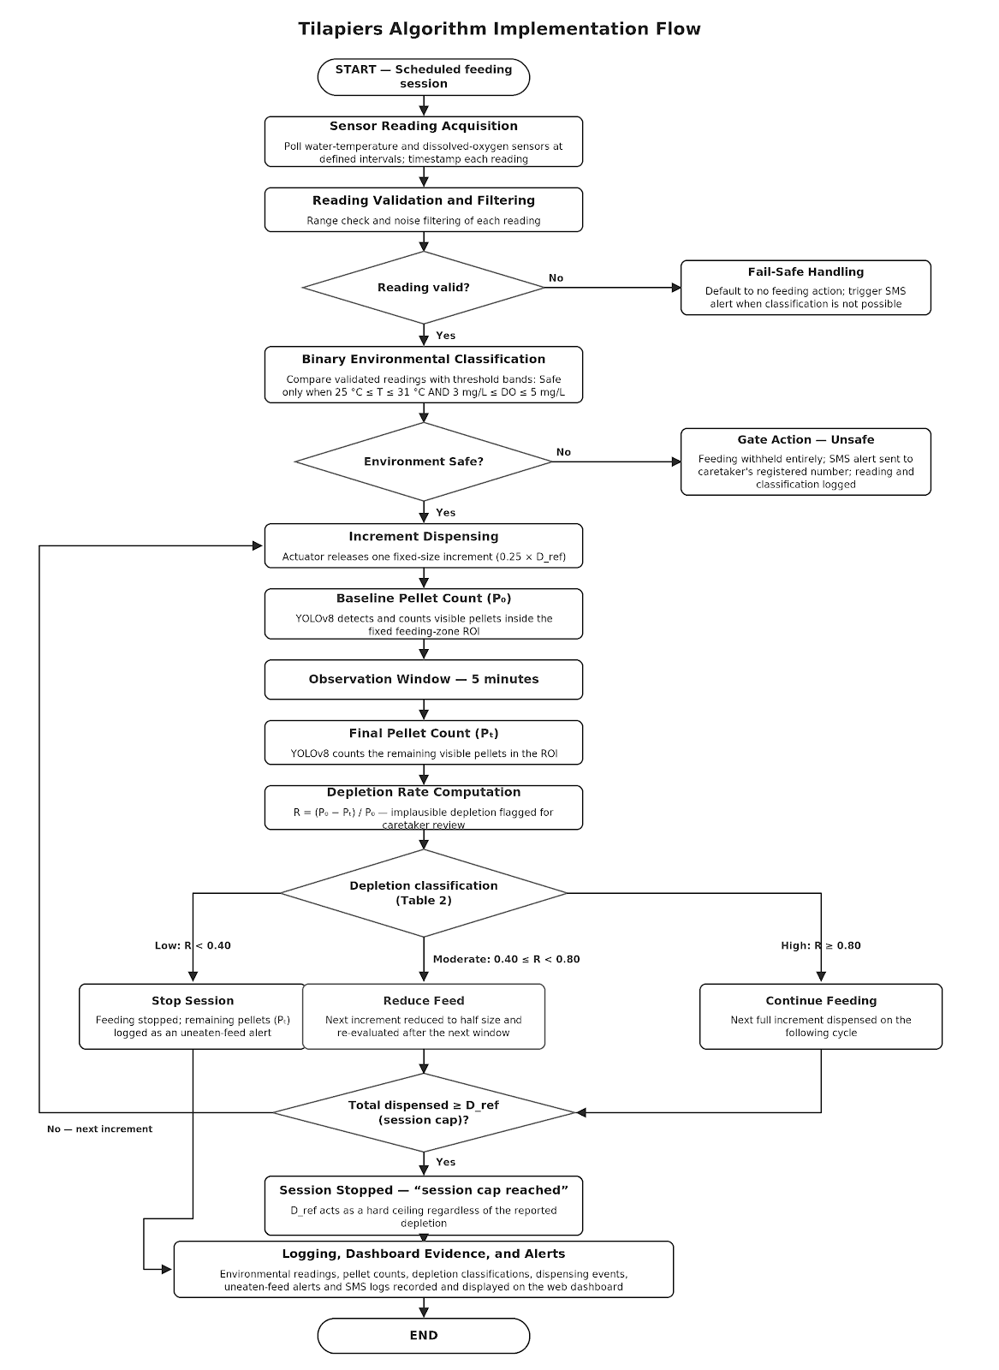

Figure 23 Tilapiers Algorithm Implementation Flow

Environmental Verification Gate
The environmental verification gate is the first stage of every feeding decision. It does not require model training because its decisions are based on the predefined threshold bands adopted for the study.

Step 1 - Sensor Reading Acquisition
The system polls the water-temperature sensor and the dissolved-oxygen sensor at defined intervals and timestamps each reading. One hour before each scheduled feeding session, the monitoring modules evaluate the latest readings and pass control to the Temperature Status or DO Status module when a reading is not optimal.

Step 2 - Reading Validation and Filtering
Each reading is checked for validity and filtered to reduce noise. An invalid or missing reading defaults the system to no feeding action and, where the failure prevents environmental classification entirely, triggers an SMS alert as a precaution.

Step 3 - Binary Classification
The validated readings are compared with the threshold bands in Table 2 of Chapter 1. The environment is classified as Safe only when the temperature is within 25 °C to 31 °C and the dissolved oxygen is at least 5 mg/L (the minimum feeding threshold) simultaneously. If either parameter, or both, falls outside its range, the environment is classified as Unsafe. The parameters are not averaged or offset against each other, since a favorable temperature reading cannot compensate for unfavorable dissolved oxygen.

Step 4 - Gate Action
When the state is Unsafe, feeding is withheld entirely, an SMS alert is sent to the caretaker's registered mobile number, and the readings and classification are logged. When the state is Safe, the Fish Feeding Evaluation Module passes control to the Safe Feeding Execution Module and the feeding decision algorithm is engaged.

YOLOv8 Feed-Pellet Detection and Counting
YOLOv8 is used as the object detection component of Tilapiers. Its primary function is to detect and count visible feed pellets within the defined feeding-zone ROI after each dispensed increment. The model provides the location, class, and confidence of each detected pellet, where the class is one of tilapia, feed pellets, air bubbles, or fish waste. It is engaged only after the environmental gate has classified the environment as Safe.
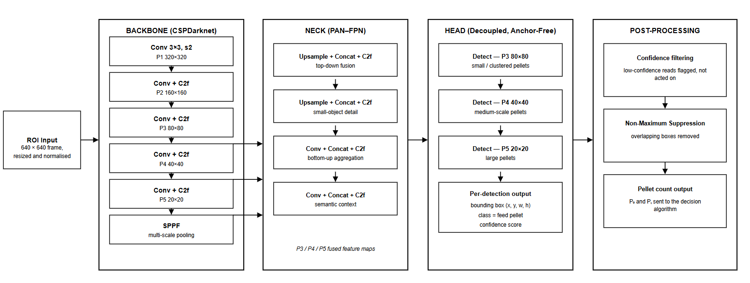

Figure 24 YOLOv8 Architecture

Step 1 - Video Frame Input
The overhead camera module captures video of the feeding zone. Frames are sampled at the start and end of each observation window for pellet counting, and a corresponding frame or short clip is retained as detection evidence for the dashboard.

Step 2 - ROI Extraction
The frame is restricted to the fixed feeding-zone ROI so that only pellets within the defined region are counted. Because the camera position and ROI definition are fixed for the tank setup, the same region is evaluated consistently across sessions.

Step 3 - Image Preprocessing
The ROI image is resized and normalized according to the required YOLOv8 input format so that frames are processed consistently.

Step 4 - Feature Extraction
YOLOv8 processes the preprocessed image and extracts visual features that help distinguish feed pellets from the background, such as edges, shapes, textures, and colors.

Step 5 - Feature Processing
The extracted features are processed through the YOLOv8 network at different spatial scales. This allows the model to recognize tilapia, feed pellets, air bubbles, and fish waste, including pellets closely clustered together, amid water movement and fish activity.

Step 6 - Pellet Detection
The YOLOv8 detection head generates predictions containing bounding boxes, the class label (tilapia, pellet, bubble, or waste), and confidence scores.

Step 7 - Confidence Filtering
Predictions below the predefined confidence threshold are filtered out. Depletion readings that fall below the minimum detection-confidence threshold are suppressed: the system holds the previous state and flags a low-confidence read rather than feeding that reading into the decision logic.

Step 8 - Non-Maximum Suppression
Non-Maximum Suppression (NMS) is applied to remove redundant overlapping detections. When multiple bounding boxes represent the same pellet, the prediction with the higher confidence is retained.

Step 9 - Pellet Count Output
The remaining detections of the pellet class are counted to produce the pellet count for the frame. The counts at the start (P0) and end (Pt) of the observation window, together with the detection evidence, are forwarded to the feeding decision algorithm and the dashboard.

Depletion-Responsive Feeding Decision Algorithm
The feeding decision algorithm serves as the final decision-making component of Tilapiers. It combines the environmental gate's Safe/Unsafe state with the pellet counts from YOLOv8 to determine each feeding action. Like the environmental gate, it does not require model training because it operates on predefined conditions and thresholds. It follows the algorithm defined in Chapter 1 and is limited to Months 2 to 4 of the culture period.
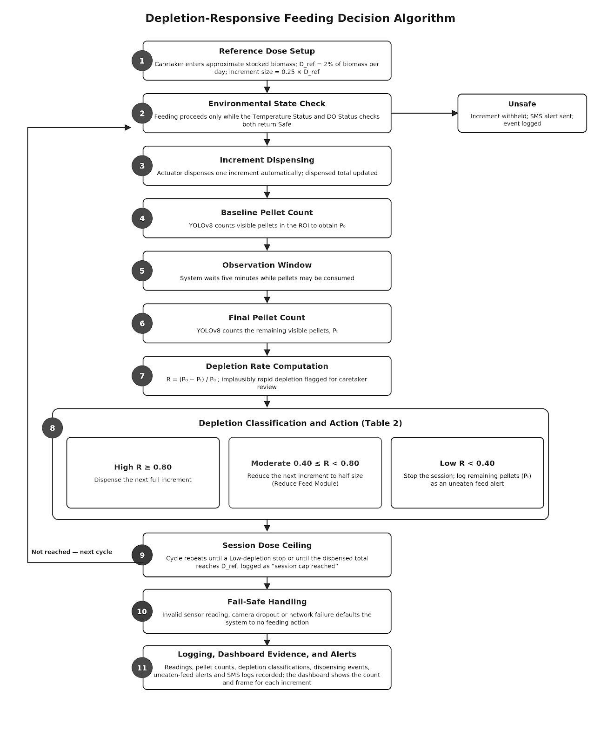

Figure 25 Depletion-Responsive Feeding Decision Algorithm

Step 1 - Culture Stage Selection and Reference Dose Setup
At stocking, the caretaker enters the sampled average body weight (ABW, obtained by sampling 50 pieces per 1,000 stock) and the number of stocks, which together give the approximate stocked biomass, and selects the culture stage. The system classifies the stage from the ABW using the bands of Table 1 in Chapter 1: 36–99 g corresponds to Month 2 (starter; 5% of biomass per day, 4 feedings per day, starter floater), 127–221.5 g to Month 3 (grower; 3%, 3 feedings per day, grower floater), and 256.5–361.5 g to Month 4 (finisher; 2%, 2 feedings per day, finisher floater). An ABW outside these bands is flagged, and the last valid stage is held. The system then computes the fixed reference starter dose (D_ref), the per-session portion of the daily ration, per BFAR-NCR extension guidelines:
D_ref = (ABW × stage rate × No. of Stocks) / (1000 × stage frequency)
D_ref is recalibrated from sampling data on a weekly basis and whenever the caretaker updates the stocking figures, such as after harvest, restocking, or a change of culture stage. The stage is never detected automatically, and the dose is not recomputed per session. The increment size is set to 0.25 × D_ref.

Step 2 - Environmental State Check
Before each increment is released, the current environmental state is verified. Feeding proceeds only if the state is Safe.

Step 3 - Increment Dispensing
The actuator automatically dispenses one increment without requiring caretaker approval, and the dispensed total is updated.

Step 4 - Baseline Pellet Count
After dispensing, YOLOv8 counts the visible pellets in the ROI to obtain the baseline count (P0).

Step 5 - Observation Window
The system waits for the defined five-minute observation window, during which the pellets may be consumed.

Step 6 - Final Pellet Count
At the end of the window, YOLOv8 counts the remaining visible pellets (Pt).

Step 7 - Depletion Rate Computation
The depletion rate is computed as follows. Implausibly rapid depletion, inconsistent with the expected depletion timeframes reported in the literature, is flagged for caretaker review rather than automatically classified as High depletion.
R = (P0 − Pt) / P0

Step 8 - Depletion Classification and Action
The depletion rate is classified according to Table 3 of Chapter 1. If R ≥ 0.80, the depletion is classified as High and the next full increment is dispensed. If 0.40 ≤ R < 0.80, the depletion is classified as Moderate and the next increment is reduced to half size through the Reduce Feed Module, which re-evaluates depletion after the next window to restore the full increment, continue at the reduced size, or terminate feeding. If R < 0.40, the depletion is classified as Low, the session is stopped, and the remaining pellets (Pt) are logged as an uneaten-feed alert. The 0.80 and 0.40 cut-offs and the five-minute window are initial values to be confirmed or adjusted during pilot calibration.

Step 9 - Session Dose Ceiling
The cycle repeats until the session ends by a Low-depletion stop or until the total dispensed feed reaches D_ref, at which point the session is stopped and logged as "session cap reached." The reference dose acts as a hard ceiling regardless of how consistently the detector reports high depletion.

Step 10 - Fail-Safe Handling
An invalid sensor reading, camera dropout, or network failure defaults the system to no feeding action.

Step 11 - Logging, Dashboard Evidence, and Alerts
The environmental readings, pellet counts, depletion classifications, dispensing events, uneaten-feed alerts, and SMS alert logs are recorded by the maintenance and logging module. The web dashboard displays the pellet count and the corresponding frame or short clip for each dispensed increment so that the caretaker can review what the system observed and acted on.

Model Training and Parameter Configuration
The YOLOv8 models were trained using a custom dataset prepared by the researchers, since the pellets used in this study (2.8–4.3 mm) are larger than the 2 mm pellets of the referenced system and detection performance cannot be assumed to transfer. Images were captured from the fixed overhead camera position over the feeding-zone ROI at the tank setup, before and after feed dispensing, and covered Tateh ExtruFloat Premium feed pellets (starter, grower, and finisher sizes), tilapia, air bubbles, and fish waste, and the variations expected in operation, such as different times of day, lighting conditions, water clarity, pellet densities, and the presence of air bubbles, fish waste, reflections, and fish in the frame. Each visible tilapia, feed pellet, air bubble, and piece of fish waste was manually annotated with a bounding box under its class (tilapia, pellets, bubbles, or waste), so that the model learns to distinguish pellets from the objects that resemble them.
The dataset consisted of 309 images, divided into 221 images for training (71.5%), 59 for validation (19.1%), and 29 for testing (9.4%) to support model development and unbiased performance evaluation, with each of the four classes represented in every set. To prevent near-identical consecutive frames from appearing in more than one set, the division was made by feeding session or video rather than by individual frame. Data augmentation (for example, adjustments to brightness, contrast, blur, and orientation) was applied to the training set only to improve robustness to lighting and water-clarity variation.
The candidate variants (YOLOv8s, YOLOv8-OBB, YOLOv9s, YOLOv11s, YOLOv12s, and YOLO 26s) were fine-tuned from pretrained weights and trained under the same dataset and settings for 100 epochs at an image size of 1990 × 1080 pixels on a Google Colab T4 GPU, for the comparison in Table 9. The inference time (ms/frame) in Table 9 was measured on the same Google Colab T4 GPU. The selected configuration was the one that provided suitable validation performance, including for each class, while minimizing overfitting and meeting the inference-time constraint of the deployed hardware. The test set was kept separate from the training and validation sets and was used only for the final evaluation of the model.
The environmental verification gate and the depletion-responsive feeding decision algorithm do not require model training because they operate using predefined conditions. Their threshold values (temperature and dissolved-oxygen bands, depletion-rate tiers, increment size, and observation window) are based on the sources identified during requirement gathering and will be refined through the study's pilot calibration and sensitivity analysis.

Testing and Operating Procedure

Testing Strategy
Testing follows the test-level structure defined in ISO/IEC/IEEE 29119, applied across both the software and the integrated hardware-software system, and is further organized around the ISO/IEC 25010 quality characteristics for non-functional verification. Functional suitability, performance efficiency, and reliability are the characteristics verified through objective testing, as specified in Chapter 1, Statement of the Problem 5; usability and security are checked as supplementary characteristics. Table 11 summarizes the testing strategy.
Test Level / Characteristic | Technique | Target Component | Acceptance Basis
Unit Testing | Automated test scripts (per-function assertions), run via CI/CD on every commit. | Individual decision-algorithm functions, stage-classification and D_ref computation, sensor-reading parsers, API handlers. | All unit tests pass; no unhandled exceptions on boundary values (e.g., R = 0.8, R = 0.4; ABW = 99, 100, 126, 127, 221.5, 222, 256.5, 361.5, 362 g).
Integration Testing | Controlled test harness feeding synthetic sensor values and pellet counts into the pipeline. | Temperature/DO Monitoring-to-Status path; Fish Feeding Evaluation-to-Safe Feeding Execution path; Safe Feeding Execution/Reduce Feed-to-actuator path. | Correct state transitions (Safe/Unsafe; High/Moderate/Low depletion) for all defined input combinations in Tables 2 and 3, Chapter 1.
System Testing (end-to-end) | Scripted operational scenarios executed on the fully assembled prototype at the BFAR tank, for each stage configuration. | Full feeding session from Water Temperature/DO Monitoring through Fish Feeding Evaluation, Safe Feeding Execution (or Reduce Feed), dashboard update, and SMS dispatch via the Temperature/DO Status modules. | Observed system behavior matches the documented algorithm and the Table 3 (Chapter 1) response classification for each scenario.
Functional Suitability (ISO/IEC 25010) | Requirements traceability check against the SRS. | All operational modules listed in Table 6, including Profile Management, Maintenance, and Security. | Every functional requirement in the SRS is traceable to an implemented and tested feature.
Performance Efficiency | Latency benchmarking (recommendation-to-execution); inference-time measurement on the deployed unit. | Decision engine, actuator command path, YOLOv8 inference. | Latency within the threshold defined for Objective 5; inference time within the acceptable system latency.
Reliability | Extended uptime observation; forced sensor/camera dropout tests; repeated forced-Unsafe SMS tests. | Full system. | System defaults safely to no-feeding action on any dropout, per the fail-safe delimitation in Chapter 1.
Usability (supplementary) | System Usability Scale (SUS) administered to a subset of evaluators; heuristic walkthrough. | Web dashboard. | SUS score interpreted per standard SUS bands (Above Average or higher).
Security (supplementary) | Authentication and access-control review of the dashboard and API. | Main Menu/Authentication Module and Profile Management Module access control; backend API endpoint protection. | No unauthenticated access to control endpoints; caretaker data (mobile number, biomass estimate) stored with basic access controls.

Table 11 Testing Strategy by Level and ISO/IEC 25010 Characteristic

Validation of Strategy Employed
- Detection validation: YOLOv8 pellet counts on the held-out test set are compared against manually verified ground-truth counts to compute precision, recall, F1-score, mAP, and a confusion matrix, overall and for each class, directly operationalizing Objective 5's detection-performance requirement.
- Sensor validation: Temperature and DO readings are cross-checked against calibrated reference instruments at multiple points across the operating range, with percent error computed and any drift corrected before field deployment.
- Dose validation: The D_ref values computed by the system for sample ABW, stock-count, and stage inputs are compared with hand-computed values from the Chapter 1 formula and Table 1.
- Depletion-tracking validation: Pellet-depletion rate computed by the vision pipeline is compared against a manually observed depletion count within the same observation window, following the same validation logic applied by Riyandani et al. (2023), to quantify how closely the vision-derived proxy tracks the manually verified ground truth, per Objective 5.
- Alerting validation: SMS delivery success rate and delivery latency are logged across repeated forced-Unsafe test conditions to validate the reliability of the third-party SMS gateway/GSM module, acknowledging the delimitation that ultimate delivery still depends on cellular network availability at the deployment site.
- End-to-end latency validation: Timestamps are logged at each pipeline stage (sensor read → classification → detection → decision → actuator execution) to compute recommendation-to-execution latency under normal operating load.

System Operating Procedure
- Initial setup: via the Main Menu and Authentication Module, the caretaker logs in and enters the sampled average body weight and number of stocks (the approximate stocked biomass), selects the culture stage, and enters the registered mobile number.
- Reference dose computation: the system classifies the stage from the ABW and computes D_ref from the stage-specific feeding rate and frequency, per BFAR-NCR guidelines, and sets the increment size at 0.25 × D_ref.
- Continuous background monitoring: the Water Temperature Monitoring and Dissolved Oxygen Monitoring modules poll continuously; the Temperature Status and DO Status modules classify each as Safe/Unsafe and alert the caretaker via SMS if Unsafe.
- Feeding evaluation: one hour before each scheduled session (four, three, or two sessions per day for the starter, grower, and finisher stages, respectively), the Fish Feeding Evaluation Module checks both status classifications; if both are Safe, control passes to the Safe Feeding Execution Module.
- Automated feeding when Safe: the Safe Feeding Execution Module dispenses the reference dose in fixed increments, using YOLOv8 pellet detection to compute depletion rate; Moderate depletion routes to the Reduce Feed Module, Low depletion stops feeding, and total dispensed feed never exceeds D_ref.
- Alerting when Unsafe: if either environmental check fails, feeding is withheld, the event is logged, and an SMS alert is sent.
- Caretaker review and upkeep: the caretaker reviews logs, alerts, and detection evidence via the dashboard, responds to the weekly Saturday SMS cleaning reminder for the camera and feeder, and manages staff and data-security functions through the Profile Management and Security modules as needed.
- Dose update: the caretaker re-enters the sampled ABW and stocking figures weekly, and after harvest, restocking, or a change of culture stage, to recompute D_ref.

Project Evaluation
Project evaluation measures the system's quality as perceived by projected end-users and subject-matter experts, complementing the objective technical benchmarks obtained during testing. Evaluation follows ISO/IEC 25010:2011 as its structuring standard, consistent with Objective 5 of Chapter 1.
Evaluators. Thirty (30) evaluators are recruited via purposive sampling into three groups of ten: IT/software engineering experts, BFAR-NCR/aquaculture technical personnel, and prospective end-users (tilapia farmers and hobbyists), as described under Research Design.
Instrument. A researcher-made questionnaire anchored on the eight ISO/IEC 25010 quality characteristics (functional suitability, performance efficiency, compatibility, usability, reliability, security, maintainability, and portability) is administered using a five-point Likert scale (5 = Strongly Agree/Excellent to 1 = Strongly Disagree/Poor). Functional suitability, performance efficiency, and reliability, the characteristics named in Chapter 1, Statement of the Problem 5, are reported as the primary results, with the remaining characteristics reported as supplementary.
Procedure. Each evaluator receives a live demonstration and a supervised hands-on session with the deployed prototype at the BFAR tank (or, where field access is impractical, a recorded demonstration and a dashboard walkthrough), followed by questionnaire administration and an open-ended feedback item.
Weighted Mean Range | Verbal Interpretation | Statistical Treatment
4.20 – 5.00 | Excellent | Weighted mean per ISO/IEC 25010 characteristic and overall; standard deviation to gauge rating consistency across the three evaluator groups; one-way ANOVA (or Kruskal–Wallis, if data are non-normal) to test whether ratings differ significantly across groups.
3.40 – 4.19 | Very Satisfactory
2.60 – 3.39 | Satisfactory
1.80 – 2.59 | Fair
1.00 – 1.79 | Poor

Table 12 Statistical Treatment and Verbal Interpretation Scale for Project Evaluation

Work Plan (Work Breakdown Structure)
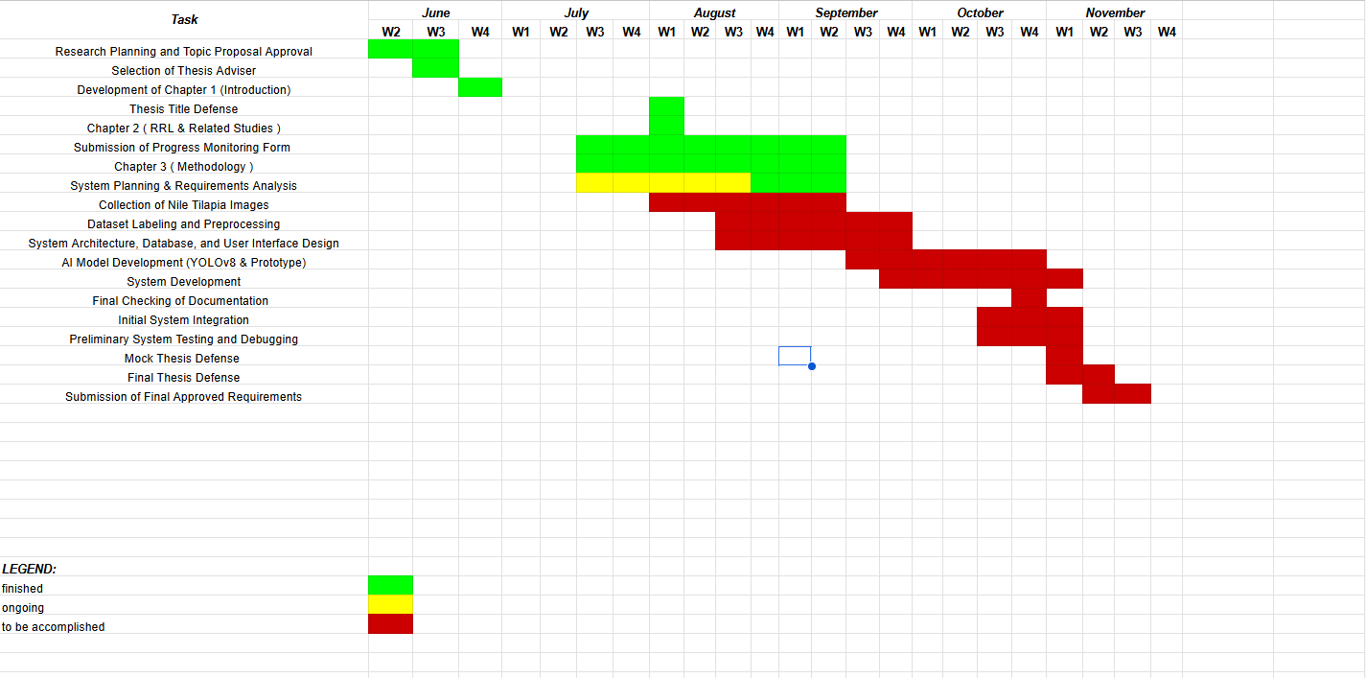

Figure 26 Gantt Chart
The Gantt Chart presents the updated Work Breakdown Structure (WBS) for the project's estimated twenty-four-week development timeline. It outlines the scheduled activities and target periods for each major phase, including research planning and proposal approval, thesis chapter preparation, system planning and requirements analysis, image collection (tilapia, feed pellets, bubbles, and waste), dataset labeling and preprocessing, system architecture and user interface design, AI model development using YOLOv8, system development, system integration, testing and debugging, documentation, thesis defense, and submission of the final approved requirements. The Gantt chart also uses color coding to indicate completed, ongoing, and pending activities, providing a clear overview of the project's progress and remaining tasks.

Potential for Commercialization
This section evaluates Tilapiers' potential to become a commercially viable system beyond its use as a thesis prototype by examining its target market, competitive advantages, product development roadmap, go-to-market strategy, and proposed business model.

Market Model
Nile tilapia is the Philippines' second most-farmed aquaculture species, with the sector contributing 304,326.59 metric tons, roughly 6.91% of the country's total fisheries production, in 2020, produced across 60,056 registered grow-out farms and 623 hatcheries nationwide, the majority privately owned (Bureau of Fisheries and Aquatic Resources [BFAR] & Department of Agriculture [DA], 2022). Central Luzon alone accounts for 45.71% of national tilapia production, followed by CALABARZON at 23.84% (BFAR & DA, 2022). Feed is consistently reported as the single largest cost driver in tilapia production, accounting for approximately 56.9% to 68% of total production cost depending on farm scale and region (BFAR & DA, 2022), the specific inefficiency Tilapiers' depletion-responsive dosing is designed to reduce. This directly supports the market-sizing logic below.
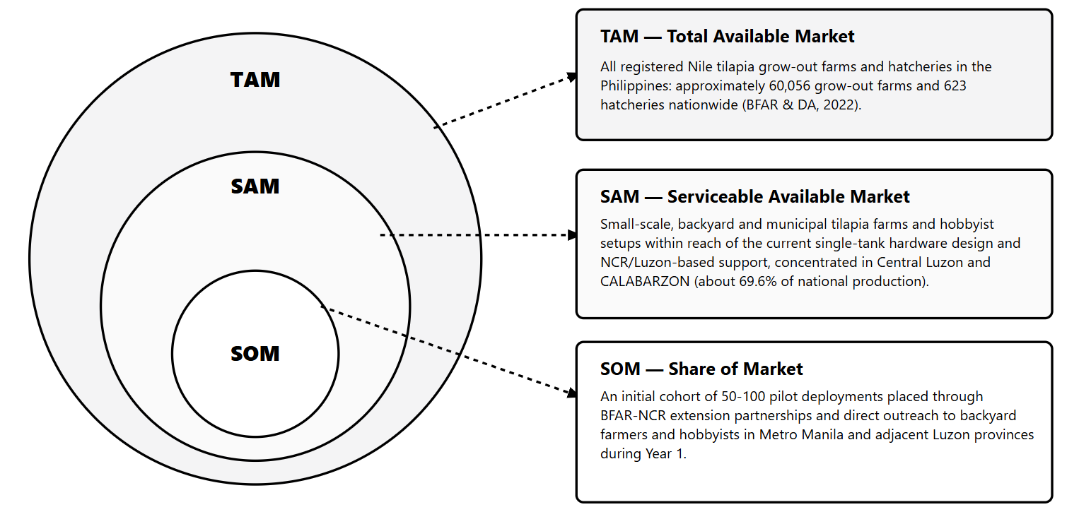

Figure 27 Market Model
These figures are drawn from the Philippine Tilapia Industry Roadmap 2022–2025 (BFAR & DA, 2022) and should be revisited against more recent Philippine Statistics Authority and BFAR releases as they become available, since industry figures are updated periodically and the roadmap's own base year is 2020.

Measurable Benefits
Tilapiers' central differentiator is that it converts feeding, the single largest and most variable cost component in tilapia production, from a schedule- or judgment-based practice into a closed-loop, observation-driven process gated on measured environmental safety. Its measurable benefits to buyers/users include:
- Reduced feed wastage: By continuing, halving, or stopping increments based on observed pellet depletion rather than dispensing a full ration regardless of appetite, and by capping every session at the stage-specific reference dose, the system targets the overfeeding losses identified in Chapter 1 as a major contributor to the feed cost that already represents 56.9%–68% of total production cost (BFAR & DA, 2022).
- Stage-appropriate dosing: The reference dose is computed from the BFAR-NCR feeding rate and frequency for the starter, grower, or finisher stage, so the same unit can serve a tank through months 2 to 4 of culture without separate hardware or manual ration calculation for each session.
- Improved water-quality outcomes: Uneaten-feed flagging and the environmental safety gate reduce the incidence of decomposing excess feed, a key driver of bacterial loading and mortality risk described in Chapter 1.
- Reduced feeding losses during unsafe conditions: Feeding is automatically withheld, rather than continued out of habit or a rigid schedule, when temperature or dissolved oxygen falls outside the optimal range, avoiding feed loss and stress-related mortality during thermal or hypoxic stress.
- Labor and attention savings: Automated dosing and SMS alerting remove the need for a caretaker to be physically present to judge appetite or check water parameters before every feeding session.
- Accessibility for non-specialist users: Hobbyists and small-scale farmers gain access to an automated safeguard against overfeeding without needing laboratory-grade measurement equipment or aquaculture expertise, consistent with the Significance section of Chapter 1.

Three-Year Product Roadmap

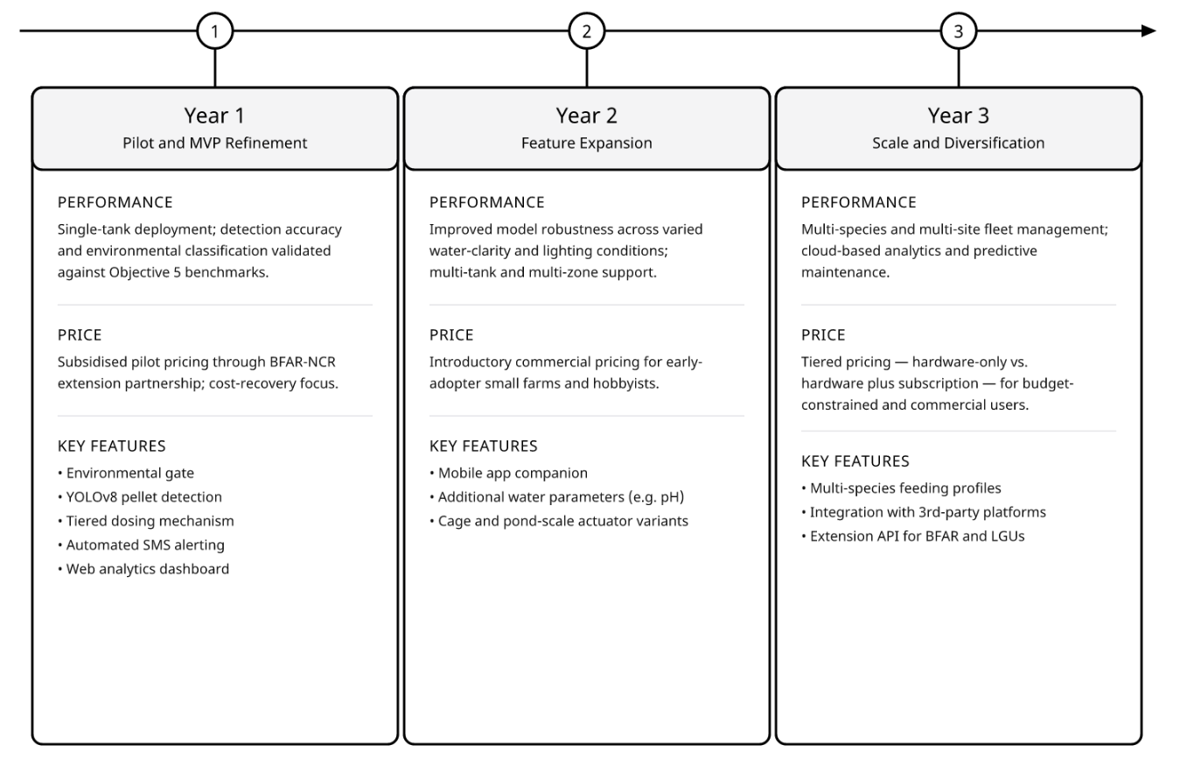

Figure 28 Three-Year Product Roadmap
Figure 28 presents a three-year product roadmap divided into three distinct development phases: Year 1 (Pilot and MVP Refinement), Year 2 (Feature Expansion), and Year 3 (Scale and Diversification). Year 1 focuses on single-tank deployment covering the starter, grower, and finisher stages within the scope of Chapter 1, subsidized pilot pricing through BFAR-NCR, and core capabilities such as YOLOv8 pellet detection and automated SMS alerting. Year 2 expands functionality by introducing multi-tank support, introductory commercial pricing, a mobile app companion, and additional water parameter sensors like pH. Finally, Year 3 aims at full scaling through multi-species fleet management, cloud-based predictive analytics, tiered subscription pricing, and third-party extension APIs.

Go-to-Market Strategy
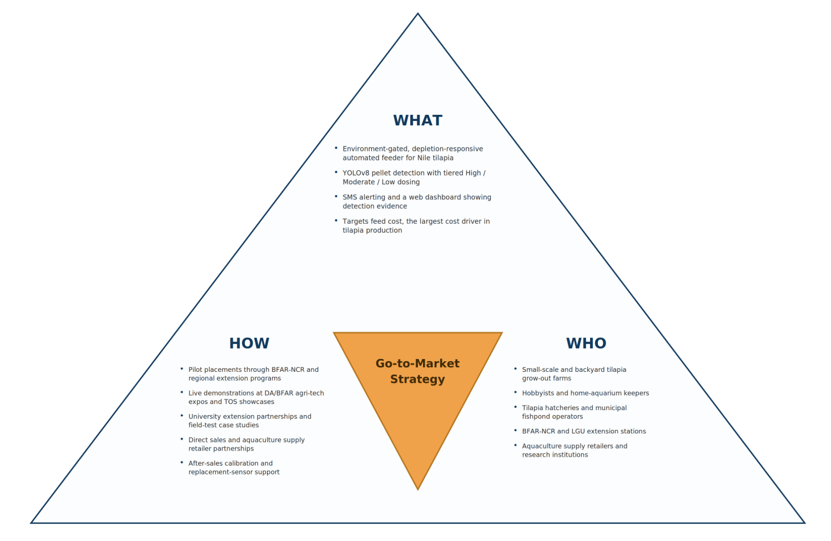

Figure 29 Go-to-Market Strategy
Distribution channels: Initial distribution through BFAR-NCR and BFAR regional extension programs, which already reach the study's identified beneficiary groups (tilapia farmers, hobbyists, and the aquaculture industry under BFAR-NCR); complemented by direct sales to backyard/hobbyist buyers and partnerships with aquaculture supply and hardware retailers.
Marketing programs: Live demonstrations at agricultural and agri-tech expos (e.g., DA/BFAR-organized events), technology outreach station (TOS) showcases, and university extension partnerships; case-study content built from the system's own field-testing results (see Acceptance Testing) to demonstrate measurable feed-cost and water-quality benefits.
Marketing plans: A phased plan aligned to the product roadmap: pilot placements and BFAR endorsement in Year 1, targeted outreach to Central Luzon and CALABARZON small-scale farms (the two highest-producing regions per BFAR & DA, 2022) in Year 2, and broader e-commerce and reseller-network expansion in Year 3.
Other marketing concerns: Given that most target farms are small-scale and cost-sensitive, messaging emphasizes total feed-cost savings and water-quality risk reduction over technical specifications, and after-sales support (calibration assistance, replacement sensors) is positioned as part of the value proposition given the field's reliance on continuous, dependable operation.

Business Model
Value Chain Position. Tilapiers positions itself as an input-supply-stage technology provider within the tilapia value chain described by BFAR and DA (2022), alongside feed and equipment suppliers, rather than as a producer, processor, or trader, supplying a device-plus-software layer that improves feed-input efficiency at the farm-production stage.
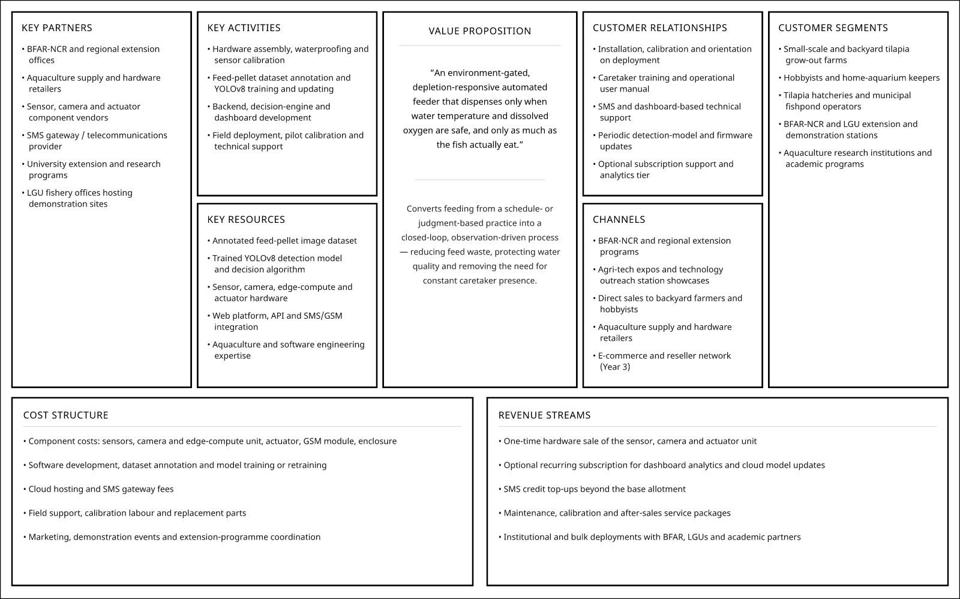

Figure 30 Business Model Summary
Overall, Tilapiers' commercialization case rests on addressing a cost driver, feed, at 56.9%–68% of production cost (BFAR & DA, 2022), that is both large and directly observable through the system's own telemetry, giving any future pilot a straightforward basis for demonstrating return on investment to prospective adopters.

References
Abrajano, J. V., Apanay, J., Botangen, K. A., Nabua, J., & Peña, C. F. (2024). IoT-based water quality monitoring system in Philippine off-grid communities. arXiv. https://arxiv.org/abs/2410.14619
Bureau of Fisheries and Aquatic Resources Regional Office No. 8. (n.d.). Tilapia in ponds [Techno Guide Series flyer]. Department of Agriculture.
Cai, C., Tan, S., Wang, X., Zhang, B., Fang, C., Li, G., Xu, L., Liu, S., & Wang, R. (2025). Real-time detection of hypoxic stress behavior in aquaculture fish using an enhanced YOLOv8 model. Aquaculture International, 33, Article 207. https://doi.org/10.1007/s10499-025-01886-0
Chen, C. H., Wu, Y. C., Zhang, J. X., & Chen, Y. H. (2022). IoT-based fish farm water quality monitoring system. Sensors, 22(17), Article 6700. https://doi.org/10.3390/s22176700
Department of Environment and Natural Resources. (2016). DENR Administrative Order No. 2016-08: Water quality guidelines and general effluent standards of 2016. Republic of the Philippines.
Hamed, S. A., El-Kassas, S., Abo-Al-Ela, H. G., Abdo, S. E., Abou-Ismail, U. A., & Mohamed, R. A. (2024). Temperature and feeding frequency: Interactions with growth, immune response, and water quality in juvenile Nile tilapia. BMC Veterinary Research, 20, Article 528. https://doi.org/10.1186/s12917-024-04366-4
Hossam, R., Heakl, A., & Gomaa, W. (2024). Precision aquaculture: An integrated computer vision and IoT approach for optimized tilapia feeding. arXiv. https://arxiv.org/abs/2409.08695
Islam, S. M. M., Akhter, F., Jahan, I., Rashid, H., & Shahjahan, M. (2022). Alterations of oxygen consumption and gills morphology of Nile tilapia acclimatized to extreme warm ambient temperature. Aquaculture Reports, 23, Article 101089. https://doi.org/10.1016/j.aqrep.2022.101089
Jocher, G., Chaurasia, A., & Qiu, J. (2023). Ultralytics YOLOv8 (Version 8.0.0) [Computer software]. GitHub. https://github.com/ultralytics/ultralytics
Liu, R., Liu, R., Song, G., Li, Q., Cui, Z., & Long, Y. (2022). Mitochondria dysfunction and cell apoptosis limit resistance of Nile tilapia (Oreochromis niloticus) to lethal cold stress. Animals, 12(18), Article 2382. https://doi.org/10.3390/ani12182382
Qian, R., Deng, H., Wang, Z., Zhou, L., Li, B., He, J., & Ling, J. (2026). Real-time detection of fish feeding behavior with PM-YOLO utilizing YOLOv8. Discover Applied Sciences, 8, Article 48. https://doi.org/10.1007/s44252-025-08043-5
Refaey, M. M., Zghebr, F. E., Mansour, A. T., & Mehrim, A. I. (2025). Effect of different aquaculture systems on chronic hypoxia tolerance in Nile tilapia, Oreochromis niloticus: Growth rate, physiological responses, oxidative stress biomarkers, and flesh quality. Aquaculture International, 33, Article 130. https://doi.org/10.1007/s10499-024-01799-4
Riyandani, M., Jaya, I., & Pujiyanto, A. (2023). Computer vision-based fish feed detection and quantification system. Jurnal Akuatika Indonesia, 8(1), 833–840. https://doi.org/10.30871/jagi.v7i1.5644
Romero, A. A., Dela Cruz, K., Ocampo, D., Palabasan, G., Salac, M. A., Sison, V. K., & Trinidad, E. (2023). Nile tilapia size estimation and tracking using YOLOv5 and DeepSORT. International Journal of Progressive Research in Science and Engineering, 4(8), 1–8. https://journal.ijprse.com/index.php/ijprse/article/view/959
Sangkaphet, P., Chansiri, N., Kaewklom, C., Chaleamwong, B., Wonglamai, P., Chinnachot, P., & Makdee, S. (2026). The development and field evaluation of an IoT–LoRa-based water-quality-monitoring and aeration-actuation system for tilapia cage farming. Applied Sciences, 16(11), Article 5308. https://doi.org/10.3390/app16115308
Tateh. (n.d.). Tateh ExtruFloat Premium: Feeds for tilapia [Product brochure]. https://www.tateh.com/brochure/TILAPIA_EXTRUFLOAT.pdf
Yagoub, H. M., Khogali, F. A., Yousif, R. A., & Ibrahim, M. T. (2026). Growth dynamics and resource partitioning in Oreochromis niloticus and Clarias gariepinus polyculture: Deciphering species ratios and density regimes in concrete ponds. South Asian Journal of Agricultural Sciences, 6(3), 64–69. https://doi.org/10.22271/27889289.2026.v6.i3a.267
Zhang, L., Zheng, Y., & Liu, Z. (2025). A method for detecting feeding fish in ponds based on FFishNet-YOLOv8. Computers and Electronics in Agriculture, 230, Article 109873. https://doi.org/10.1016/j.compag.2024.109873

